**MENTOR-SHIFT: A MOBILE PLATFORM SOLUTION**

**ON PERSONALIZED TUTORING**

A Capstone Project Presented to

The Faculty of the Undergraduate Program

School of Engineering and Computer Studies

Divine Word College of Legazpi

In Partial Fulfillment

of the Requirements for the Degree

BACHELOR OF SCIENCE IN INFORMATION TECHNOLOGY

By

**JADE BUBAN RAPOSA**

**IAN JAY NICCOLO DURAN BUENO**

**MARC AUSTIN KATIGBAK BONAGUA**

October 2024

**RECOMMENDATION FOR CAPSTONE PROJECT FINAL DEFENSE**

In partial fulfillment of the requirements for the Degree of Bachelor of Science in Information Technology, this Capstone Project entitled, “**MENTOR-SHIFT: A MOBILE PLATFORM SOLUTION ON PERSONALIZED TUTORING”** prepared by **Jade Buban Raposa, Ian Jay Niccolo D. Bueno and Marc Austin K. Bonagua** are hereby submitted to the Capstone Project Committee for consideration and approval.

**DHAN DAVISH ALAMO**

Adviser

In partial fulfillment of the requirements for the Degree of Bachelor of Science in Information Technology, this Capstone Project entitled, “**MENTOR-SHIFT: A MOBILE PLATFORM SOLUTION ON PERSONALIZED TUTORING”** prepared and submitted by **Jade Buban Raposa, Ian Jay Niccolo D. Bueno, and Marc Austin K. Bonagua** are hereby considered and endorsed for Final Defense.

**RHODORA FAYE A. BROSAS, MBA, MIT**

Capstone Project Coordinator

**RESULT OF THE FINAL DEFENSE**

**Project Title:** MENTOR-SHIFT: A MOBILE PLATFORM SOLUTION ON                PERSONALIZED TUTORING

**Researcher:** Jade Buban Raposa Ian Jay Niccolo D. Bueno

    Marc Austin K. Bonagua

**Place:**SoECS Conference Room **Date:** October 14, 2024 **Time:** 11:30 AM

FINAL DEFENSE COMMITTEE       ACTION TAKEN

**JP REMAR A. SERRANO \_\_\_\_\_\_\_\_\_\_\_\_\_\_\_\_**

Panel Member

**REILAN L. CADUBLA             \_\_\_\_\_\_\_\_\_\_\_\_\_\_\_\_**

Panel Member

**DHAN DAVISH V.ALAMO**

Adviser

**RHODORA FAYE A. BROSAS, MBA, MIT**

Capstone Project Coordinator

**CAPSTONE PROJECT 2 COMPLETION**

**Project Title:** MENTOR-SHIFT: A MOBILE PLATFORM SOLUTION ON PERSONALIZED TUTORING

**Researcher:** Jade Buban Raposa, Ian Jay Niccolo D. Bueno

Marc Austin K. Bonagua  

**Degree Program:** Bachelor of Science in Information Technology

**Final Defense Completed on:**October 14, 2024

**CAPSTONE PROJECT COMMITTEE**

FINAL DEFENSE COMMITTESIGNATURES

**JP REMAR A. SERRANO \_\_\_\_\_\_\_\_\_\_\_\_\_\_\_\_**

Panel Member

**REILAN  L. CADUBLA \_\_\_\_\_\_\_\_\_\_\_\_\_\_\_\_**

Panel Member

**DHAN DAVISH V. ALAMO \_\_\_\_\_\_\_\_\_\_\_\_\_\_\_\_**

Adviser

**VICTOR Q. PARILLAS JR., DIT**

Chairman

**CERTIFICATE OF APPROVAL**

This is to certify that the Capstone Project of:

**JADE BUBAN RAPOSA**

**IAN JAY NICCOLO D. BUENO**

**MARC AUSTIN K. BONAGUA**

Has been approved by the Capstone Project Committee in partial fulfillment of the Requirements of the Bachelor of Science in Information Technology School of Engineering and Computer Studies.

**DHAN DAVISH ALAMO**

Adviser

**RHODORA FAYE A. BROSAS, MBA, MIT**

Capstone Project Coordinator

**ENGR. MARBEN S. RAMOS, LPT**

OIC – Dean

**EXECUTIVE SUMMARY**

**Project Title:** MENTOR-SHIFT: A MOBILE PLATFORM SOLUTION ON PERSONALIZED TUTORING

**Researcher:** Jade Buban Raposa Ian Jay Niccolo D. Bueno

    Marc Austin K. Bonagua

**Keywords:**  Educational Technology, Mentorship, Mobile Learning, Personalized Learning

The "Mentor-Shift: A Mobile Platform Solution for Personalized Tutoring" is an application designed to enhance the mentorship and tutoring experience in academic settings. This mobile platform addresses several critical gaps in the current educational support systems, including the difficulty in finding suitable mentors, the lack of personalized learning approaches, and the challenges in tracking academic progress and certification. By enabling seamless communication between students and educators and fostering flexible and structured mentorship opportunities, Mentor-Shift provides a comprehensive solution that promotes effective mentorship within a mobile platform. Key features of the system include:

The platform enables users to select their roles during sign-up, providing tailored access to features based on their role as either a student or educator. Students can search for mentors, request mentorship, and access educational resources, while educators can manage mentorship requests and provide relevant materials. The streamlined mentorship request process allows educators to accept or decline requests based on their availability and expertise, ensuring personalized mentorship aligned with students' academic goals.

Educators can create and manage courses, post study materials, and assign activities such as quizzes and lessons. These resources become available to students once their mentorship request is approved, facilitating structured learning. The platform also allows educators to monitor student progress, input reports, and upload certificates for students who successfully complete their tasks. Students can download these certificates as proof of their achievements and progress.

A built-in messaging system enables real-time communication between mentors and mentees, fostering collaboration and enhancing the learning experience. This feature ensures continuous engagement and support throughout the mentoring process.

The development of Mentor-Shift follows the Agile Lean approach, emphasizing iterative development, continuous improvement, and user feedback to create a user-friendly and highly adaptable platform. This ensures the app remains flexible, responsive to user needs, and capable of evolving with future educational trends. By promoting collaborative learning environments, Mentor-Shift supports both mentors and mentees in achieving academic success.

**ACKNOWLEDGEMENT**

Without the assistance of the individuals behind this project, this work would not have been possible.

**RHODORA FAYE A. BROSAS, MBA, MIT ,** Capstone Project Coordinator, her guidance drove to the completion of this project.

**DHAN DAVISH ALAMO,** for his unwavering support, guidance and motivation which helped the completion of the project.

**JP REMAR A. SERRANO** and **REILAN L. CADUBLA** , panel members, for their constructive criticisms and suggestions significantly enhanced this project.

**FAMILY,** who have always been there, showing them support throughout their education.

**FRIENDS,** who have been the main source of happiness at school, offering their warmth and comfort to get through during tough times. Their understanding has helped in navigating the challenges of college life with resilience and a smile.

Each played a significant role in making this project successful and they are grateful for it.

## TABLE OF CONTENTS

**Contents   Page No.**

Title Page .  .  .  .  .  .  .  .  .  .  .  .  .  .  .  .  .  .  .  .  .  .  .  .  .  .  .  .  .  .  .  .  .  .  .  .  .  . . . . . i

Recommendation for Final Defense .  .  .  .  .  .  .  .  .  .  .  .  .  .  .  .  .  .  .  .  .  .  . . . . . ii

Result of Final Defense .  .  .  .  .  .  .  .  .  .  .  .  .  .  .  .  .  .  .  .  .  .  .  .  .  .  .  .  .  . . . . . iii

Capstone Completion .  .  .  .  .  .  .  .  .  .  .  .  .  .  .  .  .  .  .  .  .  .  .  .  .  .  .  .  .  .  . . . . . iv

Certificate of Approval .  .  .  .  .  .  .  .  .  .  .  .  .  .  .  .  .  .  .  .  .  .  .  .  .  .  .  .  .  .  . . . . v

Executive Summary .  .  .  .  .  .  .  .  .  .  .  .  .  .  .  .  .  .  .  .  .  .  .  .  .  .  .  .  .  .  .  . . . . . vi

Acknowledgement .  .  .  .  .  .  .  .  .  .  .  .  .  .  .  .  .  .  .  .  .  .  .  .  .  .  .  .  .  .  .  .  . . . . . viii

Table of Contents .  .  .  .  .  .  .  .  .  .  .  .  .  .  .  .  .  .  .  .  .  .  .  .  .  .  .  .  .  .  .  .  . . . . . ix

List of Figures .  .  .  .  .  .  .  .  .  .  .  .  .  .  .  .  .  .  .  .  .  .  .  .  .  .  .  .  .  .  .  .  .  .  .  . . . . xii

List of Tables .  .  .  .  .  .  .  .  .  .  .  .  .  .  .  .  .  .  .  .  .  .  .  .  .  .  .  .  .  .  .  .  .  .  .  . . . . . xiii

**Chapter**

**1  PROJECT IDENTIFICATION**

Project Context .  .  .  .  .  .  .  .  .  .  .  .  .  .  .  .  .  .  .  .  .  .  .  .  . . . . . . 1

Description of the Existing System .  .  .  .  .  .  .  .  .  .  .  .  .  . . . . . . 6

Statement of the Problem .  .  .  .  .  .  .  .  .  .  .  .  .  .  .  .  .  .  . . . . . . 9

Objectives of the Study .  .  .  .  .  .  .  .  .  .  .  .  .  .  .  .  .  .  .  .  . . . . . 9

Purpose and Description .  .  .  .  .  .  .  .  .  .  .  .  .  .  .  .  .  .  .  . . . . . 10

Scope and Delimitation .  .  .  .  .  .  .  .  .  .  .  .  .  .  .  .  .  .  .  .  . . . . . 11

Technical Terms .  .  .  .  .  .  .  .  .  .  .  .  .  .  .  .  .  .  .  .  .  .  .  .  . . . . . 12

**Chapter**

**2  METHODOLOGY**

Software Development .  .  .  .  .  .  .  .  .  .  .  .  .  .  .  .  .  . . . . . . . . 22

Purpose, Deliverables, and Development Activities .  .  .  .  . . . . . 24

Data Gathering Techniques .  .  .  .  .  .  .  .  .  .  .  .  .  .  .  .  .  .  . . . . . 26

Sources of Data .  .  .  .  .  .  .  .  .  .  .  .  .  .  .  .  .  .  .  .  .  .  .  .  .  . . . . . 27

Survey Results .  .  .  .  .  .  .  .  .  .  .  .  .  .  .  .  .  .  .  .  .  .  .  .  .  . . . . . 28

Theoretical Framework .  .  .  .  .  .  .  .  .  .  .  .  .  .  .  .  .  .  .  .  . . . . . 40

Conceptual Framework .  .  .  .  .  .  .  .  .  .  .  .  .  .  .  .  .  .  .  .  . . . . . 42

**Chapter**

**3  REQUIREMENTS ANALYSIS AND DOCUMENTATION**

Flowchart.  .  .  .  .  .  .  .  .  .  .  .  .  .  .  .  .  .  .  .  .  .  .  .  .  .  .  .  . . . . . 45

System Architecture .  .  .  .  .  .  .  .  .  .  .  .  .  .  .  .  .  .  .  .  .  .  . . . . . 47

Software Design .  .  .  .  .  .  .  .  .  .  .  .  .  .  .  .  .  .  .  .  .  .  .  .  . . . . . 48

Database Design .  .  .  .  .  .  .  .  .  .  .  .  .  .  .  .  .  .  .  .  .  .  .  .  . . . . . 53

System Requirements .  .  .  .  .  .  .  .  .  .  .  .  .  .  .  .  .  .  .  .  .  . . . . . 56

System Tradeoffs .  .  .  .  .  .  .  .  .  .  .  .  .  .  .  .  .  .  .  .  .  .  .  .  . . . . . 60

System Design .  .  .  .  .  .  .  .  .  .  .  .  .  .  .  .  .  .  .  .  .  .  .  .  .  . . . . . 65

Project Timeline .  .  .  .  .  .  .  .  .  .  .  .  .  .  .  .  .  .  .  .  .  .  .  .  . . . . . 70

**CHAPTER**

**4  SUMMARY, FINDINGS, CONCLUSIONS, AND RECOMMENDATIONS**

Summary .  .  .  .  .  .  .  .  .  .  .  .  .  .  .  .  .  .  .  .  .  .  .  .  .  .  .  .  .

Findings .  .  .  .  .  .  .  .  .  .  .  .  .  .  .  .  .  .  .  .  .  .  .  .  .  .  .  .  .  .

Conclusions .  .  .  .  .  .  .  .  .  .  .  .  .  .  .  .  .  .  .  .  .  .  .  .  .  .  .  .

Recommendations .  .  .  .  .  .  .  .  .  .  .  .  .  .  .  .  .  .  .  .  .  .  .  .

**REFERENCES** .  .  .  .  .  .  .  .  .  .  .  .  .  .  .  .  .  .  .  .  .  .  .  .  .  .  .  .  .  .  .  .  .  .

**APPENDICES**

A Letter .  .  .  .  .  .  .  .  .  .  .  .  .  .  .  .  .  .  .  .  .  .  .  .  .  .  .  .  .  .  .  .

B Questionnaires .  .  .  .  .  .  .  .  .  .  .  .  .  .  .  .  .  .  .  .  .  .  .  .  .  .

C Source Code .  .  .  .  .  .  .  .  .  .  .  .  .  .  .  .  .  .  .  .  .  .  .  .  .  .  .  .

D User’s Manual .  .  .  .  .  .  .  .  .  .  .  .  .  .  .  .  .  .  .  .  .  .  .  .  .  .  .

E Gantt Chart .  .  .  .  .  .  .  .  .  .  .  .  .  .  .  .  .  .  .  .  .  .  .  .  .  .  .  .

**CURRICULUM VITAE** .  .  .  .  .  .  .  .  .  .  .  .  .  .  .  .  .  .  .  .  .  .  .  .  .  .  .  .  .

**LIST OF FIGURES**

**Figure no.                                        Title               Page No.**

2.1 Agile Lean Methodology .  .  .  .  .  .  .  .  .  .  .  .  .  .  .   .  .  .  . . . . . . 22

2.2 Community of Inquiry (CoI) .  .  .  .  .  .  .  .  .  .  .  .  .  .  .   .  . . . . . . 40

2.3 Conceptual Framework of the Proposed System .  .  .  .  .  . . . . . . 42

3.1 Flowchart of the Manual Process.  .  .  .  .  .  .  .  .  .  .  .  .  .  .  . . . . . 45

3.2 System Architecture of the Proposed System.  .  .  .   .  .  .  . . . . . . 47

3.3 Use-Case Diagram.  .  .  .  .  .  .  .  .   .  .  .  .  .  .  .  .  .  .  .  .  .  . . . . . . 48

3.4 Sequence Diagram.  .  .  .  .  .  .  .  .  .  .  .  .  .  .  .  .  .  .  .  .  .  . . . . . . 50

3.5 Class Diagram.  .  .  .  .  .  .  .  .  .  .  .  .  .  .  .  .  .  .  .  .  .   .  .  .  . . . . . . 51

**LIST OF TABLES**

**Table no.                                       Title               Page No.**

2.1 Activities of Agile Lean Methodology.  .  .  .   .  .  .  .  .  .  .  .  . . . . . 24

2.2 Reasons Why Students Shift.  .  .  .  .  .  .  .  .  .  .   .  .  .  .  .  . . . . . . 29

2.3 Students Mindset Before Shifting.  .  .  .  .  .  .  .  .  .  .  .   .  . . . . . . 30

2.4 Students Wish They Had Personalized Guidance And Support.  .  .  .  .  .  .  .  .  .  .  .   .  .  .  .  .  .  .  .  .  .  .  .  .  .   .   .   . . . . . 30

2.5 Biggest Obstacle Faced  In Seeking Academic Help  .  .  .  . . . . . . 31

2.6 Importance of Connecting with Mentors using Mobile App .   .  . . 32

2.7 Students Interested In Using The Propose App.  .  .  .  .  .  .  . . . . . 33

2.8 Features Preferred By Students.  .  .  .  .  .  .  .  .  .  .  .  .  .  .  .  . . . . . 33

2.9 Common Challenge Students Face According to Educators.  .  .  .  .  .  .  .  .  .  .  .  .  .  .  .  .  .   .  .  .  .  .  .  . .  .  .  .  . . . . 35

2.10 Ways Personalized Assistance Can Impact A Student’s

Academic Success and Learning Experience.  .  .  .  .  .  .   .  .  .  . . . 36

2.11 Important Skills For Students To Develop In Their Field.  .  .  .  .  . 37

2.12 Educators Comfortability In Using Mobile Apps For

Helping, Connecting, and Supporting Students.  .  .  .  .  .  .  .  . . . 38

2.13 Educators Belief in Apps For Improving And

Enhancing Student’s Knowledge.  .  .  .  .  .  .  .  .  .  .  .  .  . .  .  . . . . . 38

2.14 Features Preferred By Educators For The App.  .  .  .  .  .  .  .  . . . . . 39

3.1 User Table.  .  .  .  .  .  . .  .  .  .   .  .  .  .  .  .  .  .  .  .  .  .  .  .  .  .  .  .  .  .  .  .   53

3.2 Mentor Table.  .  .  .  .  .  .  .  .  .  .  .  .  .  .  .  .  .  .  .  .  .  .  .  .  .  .   .  .  . . 53

3.3 Mentee Table.  .  .  .  .  .  .  .  .  .  .  .  .  .  .  .  .  .  .  . .  .  .  .  .  .  .  .  .  .  . . 54

3.4 Mentorship Request Table.  .  .  .  .  .  .  .  .  .  .  .  .  .  .  .  .  .  .  .  .  .  .  .  54

3.5 Content Table.  .  .  .  .  .  .  .  .  .  .  .  .   .  .  .  .   .  . .  .  .  .  .  .  .  .  .   .   .  55

3.6 Assessment Table.  .  .  .  .  .  .  .  .  .  .  .  .   .  .  .  .   .  .  .   .  .  .   .  .  . . 55

3.7 Report Table.  .  .  .  .  .  .  .  .  .  .  .  .  .   .  .  .  .  .  .  .  .  .  .  .  .   .  .   .  .  . 56

3.8 Server Hardware Requirements.  .  .  .  .  .  .  .   .  .   .  .  .  .  .  .  .  .  .  .  57

3.9 Client Hardware Requirements.  .  .  .  .  .  .  .  .  .  .  .  .  . .  .  .   .  .  .  . 57

3.10 Recommended Software Specifications.  .  .  .  .  .  .  .  .  .  .   .  .  .  .  .  59

3.11 Technical Issue.  .  .  .  .  .  .  .  .  .  .  .  .  .  .  .  .  .  .  .  . .  .  .   .  .  .  .  .  .  60

3.12 Operational Issues.  .  .  .  .  .  .  .  .  .  .  .  .  .  .  .  .  . .  .  .  .   .  .  .  .  .  .  62

3.13 Economic Issues.  .  .  .  .  .  .  .  .  .  .  .  .  .  .  .  .  .  .  .  .  .  .  .  .  .  .  .  .  63

3.14 Non-Functional Requirements.  .  .  .  .  .  .  .  .  .  .   .  .  .  .  .  .  .  .  . . 65

3.15 Functional Requirements.  .  .  .  .  .  .  .  .  .  .  . .  .   .  .  .  .  .  .  .  .  .  . 66

3.16 Gantt Chart Using Lean Methodology.  .  .  .  .  .  .  .  .  .  .  .  .  .  .  .  . 70

# Chapter 1

**PROJECT CONTEXT**

In the ever-evolving landscape of education, engaging and effective tools are essential to meet the diverse needs of learners. The proposed project, "Mentor-Shift: A Mobile Platform Solution for Personalized Tutoring," envisions a pioneering mobile application designed to address critical gaps in the current educational support systems. These gaps include the difficulty in finding suitable mentors, the lack of learning approaches, and the challenges in tracking academic progress and certification. Mentor-Shift aligns with the 17 UNESCO Sustainable Development Goals, specifically under Quality Education (SDG-4), Decent Work and Economic Growth (SDG-8), Reduced Inequalities (SDG-10), and Sustainable Cities and Communities (SDG-11). SDG-4 encompasses various aspects, and our project focuses on addressing two of these issues: "Accessible Learning Opportunities" and "Support for Lifelong Learning." Mentor-Shift adheres to Accessible Learning Opportunities by providing a platform where students can connect with mentors anytime, anywhere, thus making educational support more inclusive and flexible. It also supports Lifelong Learning by equipping individuals with critical skills and information through personalized mentoring programs powered by mobile apps. SDG-8, or Decent Work and Economic Growth, is addressed by equipping users with the skills and knowledge necessary for meaningful employment and economic contribution. MENTOR-SHIFT aligns with SDG-10, Reduced Inequalities, by reducing educational barriers and providing mentorship opportunities for marginalized groups, ensuring that everyone has access to quality education and support. Finally, SDG-11, Sustainable Cities and Communities, is supported by digital platforms to reduce educational gaps and promote inclusive learning environments. By integrating elements of mentorship, tutoring, and peer tutoring, Mentor-Shift fosters positive relationships between mentors and mentees, facilitates collaborative learning environments, and promotes academic success. Features such as automated assessments, detailed reports, and achievement tracking enhance user engagement and provide valuable feedback to support continuous learning and improvement. Overall, the app represents a comprehensive solution that empowers users to take charge of their education, overcome obstacles, and achieve their academic goals effectively, accelerating progress toward several SDGs and creating a more equitable and sustainable future.

Personalized learning is a crucial educational strategy that tailors instruction to individual students' needs, interests, and abilities, aiming to enhance student engagement, motivation, and academic success by accommodating individual variations. Research emphasizes the importance of technology integration in creating effective personalized learning models, as discussed by Shemshack (2020), who views personalized learning as a natural human activity shaped by experiences. This aligns with Mentor-Shift's use of mobile technology to provide personalized tutoring experiences.

The benefits and challenges of personalized learning, along with the role of learning analytics, are highlighted by Khor (2023). Learning analytics can be leveraged within Mentor-Shift to track student progress and tailor mentorship accordingly. Additionally, Zhang (2020) underscores the need for collaboration across disciplines, government policies, and historical context in personalized learning, suggesting that Mentor-Shift could enhance its effectiveness through partnerships with educational institutions and policymakers.

The flexibility and personalization of learning, as seen in the Open High School Program for senior high learners, are emphasized by Mirasol (2023). Mentor-Shift supports this by allowing students to learn at their own pace and according to their preferences through its mobile-based platform. Lagman (2017) points out the challenges faced by students in one-size-fits-all learning environments, particularly those with learning difficulties. Mentor-Shift addresses this by providing customized learning paths and resources tailored to individual needs.

To improve learning efficiency and recommend appropriate content for individual learners, personalized e-learning platforms have been developed, offering tailored learning paths. This approach is embodied by Mentor-Shift, which provides tailored mentorship and educational resources to cater to specific learning needs and preferences. The combination of these studies reinforces the idea that personalized learning is an effective educational strategy that promotes individualized instruction and enhances learning results. The integration of technology, cross-disciplinary collaboration, and individualized learning experiences all contribute to creating effective personalized learning environments. As educational institutions explore and implement personalized learning approaches, it is critical to use research and practice insights to improve teaching and learning for all students. Mentor-Shift leverages these insights to provide a comprehensive, flexible, and personalized tutoring platform that addresses the diverse needs of students, ultimately enhancing their academic success and engagement.

E-learning and mobile learning (m-learning) are transformative approaches to education that leverage technology to deliver learning content, offering flexibility, accessibility, and customization. E-learning encompasses resources accessed via computers or the internet, while m-learning utilizes mobile devices like smartphones and tablets for anytime, anywhere learning. These methods have revolutionized education in the digital age.

Research by Pimmer (2016) highlights the positive outcomes of mobile learning in higher education, particularly with instructionist and hybrid designs, although evidence for broad application remains limited. Chen (2023) provides a systematic view of mobile device ownership and its implications for learning, showing students' evolving beliefs about the value of mobile technology. This underscores the importance of institutions establishing effective mobile strategies, which Mentor-Shift can leverage to enhance its platform.

Sebastian (2024) explores the flipped learning model in online environments, emphasizing its effectiveness in preparing students for a complex and ever-changing world. This model highlights the impact of educational technology on student performance and learning outcomes, which Mentor-Shift can incorporate to enhance its tutoring services. Mobo (2019) discusses the benefits of e-learning, including flexibility, accessibility, and improved academic performance through electronic tools and resources. E-learning is defined as a cost-efficient, skill-developing, and flexible learning system, aligning with Mentor-Shift's goals.

Bacolod (2022) shows how mobile learning is a flexible and innovative solution for restricted learning, especially during natural disasters and pandemics, where traditional face-to-face instruction is disrupted. This flexibility is a core feature of Mentor-Shift, allowing continuous learning despite external challenges. Fabito (2017) provides insights into the factors contributing to the effectiveness of mobile learning, highlighting students' perceptions and the key factors influencing their success in using mobile devices for learning purposes. These insights can guide Mentor-Shift in optimizing its platform for better user engagement and learning outcomes.

These studies indicate that e-learning and m-learning offer significant benefits in education, including flexibility, accessibility, and customization. Positive outcomes, such as improved academic performance and student engagement, are observed across various contexts. Effective instructional design and technological integration are essential for maximizing the benefits of these approaches. The evolving student beliefs highlight the importance of institutions establishing effective mobile strategies. Innovative models like flipped learning show promise in enhancing learning outcomes and preparing students for modern challenges. In summary, e-learning and m-learning are vital components of contemporary education, providing cost-efficient, skill-developing, and flexible learning solutions adaptable to various disruptions. Mentor-Shift leverages these insights to offer a comprehensive, flexible, and personalized tutoring platform that addresses the diverse needs of students, ultimately enhancing their academic success and engagement.

Tutorship, mentorship, and peer mentoring are integral components of educational support systems, each uniquely contributing to personal and academic development. Mentorship, as highlighted by Arnesson (2017), serves as a pedagogic tool that bridges theory and practice in higher education, emphasizing the mentor's role in students' learning and professional growth. This aligns with Mentor-Shift's goal of providing personalized guidance to enhance academic and career development. Thakare (2019) and Farheen (2018) delve into software development for online mentoring systems, recognizing the potential of mentorship to transfer knowledge and foster positive mentor-mentee relationships. This is directly relevant to Mentor-Shift's focus on creating a robust online mentoring platform.

Chung (2022) explores mobile app development aimed at enhancing online peer tutoring experiences, emphasizing the importance of both face-to-face and remote mentoring sessions. This supports Mentor-Shift's approach of integrating mobile technology to facilitate seamless mentoring interactions. Research by Gutierrez (2016) identifies cultivation phases and formal mentoring programs as key contributors to mentoring effectiveness, particularly beneficial for junior faculty members. This insight can be applied to Mentor-Shift to structure effective mentoring phases.

Bercasio (2016) and Balan (2015) examine the impact of peer mentoring on skill enhancement and research competency, demonstrating positive outcomes in problem-solving and research skill development. These findings underscore the value of peer mentoring features within Mentor-Shift. Campit (2015) and Almaden (2024) further support the efficacy of peer tutoring and mentorship in improving academic performance and entrepreneurial capacity, respectively. This highlights the broad applicability of Mentor-Shift in various academic and professional contexts.

Combo (2023) and Calo (2020) provide insights into the design and implementation of mentorship systems, focusing on research competency development and tutorial efficiency. These insights can guide the development of Mentor-Shift's features to ensure effective mentorship. Salinas (2024) and Vecaldo (2021) highlight the role of peer mentoring in improving reading performance and providing comprehensive support to practice teachers, respectively. This emphasizes the importance of peer mentoring in diverse educational settings, which Mentor-Shift aims to support.

Torres (2022) addresses the need for mobile solutions for accessing tutoring services, emphasizing the importance of reliable tutor-parent connections. This aligns with Mentor-Shift's objective to provide a reliable and accessible mobile platform for tutoring and mentoring.

These studies collectively emphasize the significant effects of mentoring, tutoring, and peer tutoring on personal and academic development. Mentorship programs offer invaluable guidance and support, fostering positive relationships between mentors and mentees, which enhance academic performance, career development, and research competency. Similarly, tutoring systems facilitate personalized learning experiences and academic success, improving reading performance, research skills, and subject proficiency among students. Peer tutoring methods and programs promote collaborative learning, mutual empowerment, and academic achievement among peers, fostering a supportive learning environment where students can share knowledge, build confidence, and improve their understanding of academic concepts. In totality, these forms of support play crucial roles in empowering individuals, promoting learning outcomes, and enhancing educational experiences across diverse areas. Mentor-Shift leverages these insights to provide a comprehensive, flexible, and personalized tutoring platform that addresses the diverse needs of students, ultimately enhancing their academic success and engagement.

The collective insights from these studies emphasize the transformative potential of personalized learning, e-learning, mobile learning, and various forms of mentorship in enhancing educational outcomes. By integrating technology, cross-disciplinary collaboration, and individualized instruction, these approaches facilitate flexible, accessible, and customizable learning experiences that cater to diverse student needs. The research highlights the importance of effective instructional design, learning analytics, and mobile strategies in maximizing the benefits of these educational methods. Additionally, the studies emphasize the significant impact of mentorship, tutoring, and peer mentoring on personal and academic development, fostering positive relationships, and promoting collaborative learning environments. These findings provide a robust foundation for the development of the Mentor-Shift app, guiding its design and implementation to ensure it effectively addresses the gaps in current educational support systems. By leveraging these research insights, Mentor-Shift aims to offer a comprehensive, flexible, and personalized tutoring platform that enhances academic success, engagement, and overall learning experiences for students.

**COMPANY PROFILE**

The Divine Word College of Legazpi (DWCL) is a private Catholic co-educational basic and higher education institution run by the Philippine Central Province of the Society of the Divine Word in Legazpi, Albay, Philippines. It was founded by Rev. Fr. Juan Carullo, a retired Army Chaplain in 1947. It offers basic and higher education programs and has two campuses, which are the North and South.

Five departments in Divine Word College of Legazpi (DWCL) include the School of Engineering and Computer Studies (SOECS), School of Education, Arts, and Sciences (SEAS), School of Hospitality Management (SHOM), School of Nursing (SON), and School of Business, Management and Accountancy (SBMA). The SOECS department, which consists of five course programs, would be the pioneer scope for the proposed mobile app. They include Bachelor of Science in Electrical Engineering (BSEE), Bachelor of Science in Civil Engineering (BSCE), Bachelor of Science in Computer Science (BSCS), Bachelor of Science in Information Technology (BSIT), and Bachelor of Library and Information Science (BLIS).

**DESCRIPTION OF THE EXISTING SYSTEM**

The tutoring industry has undergone a dramatic transformation in recent years, driven by advancements in internet platforms and mobile technology. Students worldwide can now easily access professional tutors through online services that offer on-demand sessions with interactive features such as screen-sharing and virtual whiteboards, enhancing collaboration and learning. These platforms provide tailored assistance across a wide range of subjects, making personalized tutoring more accessible than ever before.

Tools like Zoom and Google Meet have revolutionized live tutoring sessions, allowing them to be conducted virtually in settings that closely resemble conventional classrooms. These virtual environments facilitate teacher-student dialogue, debates, and immediate feedback, eliminating the need for in-person attendance and enabling participation from any location with internet access. This shift has introduced unprecedented flexibility and inclusivity into the tutoring landscape.

Mobile applications have further revolutionized the tutoring industry by providing quick access to educational resources and individualized learning experiences on smartphones and tablets. Apps like Quizlet and Duolingo promote self-directed learning by allowing users to customize their learning objectives with dynamic courses, assessments, and flashcards. This mobile-first approach not only improves accessibility but also empowers students to manage their education whenever and wherever they choose.

These advanced tutoring techniques signify a new era of adaptable, engaging, and inclusive education, highlighting a shift towards digitalization and personalized learning. The integration of mobile platforms and online tools has set the stage for a more flexible, accessible, and effective educational environment, catering to the diverse needs of modern learners.

**DESCRIPTION OF THE PROPOSED SYSTEM**

The app offers a variety of study materials, tests, and activities that match the areas of expertise of the selected mentor, making it easier for users to choose mentors based on their interests and level of experience. After completing tasks provided by mentors, users receive certificates, and they have access to resources for diverse learning that are displayed like a classroom, in which you can personalize your study habit according to your preferences. Mentor approval is required to access these study materials, which promotes relationships between mentors and mentees. Students can assess their understanding and identify areas for improvement by using the performance reports from quizzes and exams that will be maintained by the mentor. The app's main goal is to help students by making mentor selection and individualized learning experiences easier. Users can look for mentors according to standards, making sure that the mentors match their academic objectives. Once the mentor is selected, they can request for mentorship approval for the mentor to decide. After the approval of the mentor, students can then have access to a variety of study materials and each their own activities for measuring how much they’ve learned, this promotes greater comprehension and helps them to successfully handle difficulties that require skill that they’re lacking.

The app also integrates a messaging system that allows seamless communication between students and their selected mentors. This system fosters a direct and supportive relationship, enabling students to ask questions, request clarification, and receive feedback from their mentors in real time. This gives bridge for the mentor to provide notifications and updates on activities, feedback, and important study material recommendations, ensuring a continuous flow of guidance and interaction. Certificates are awarded upon completion of tasks and assessments as a way to recognize the student's progress. These certificates are manually created by the mentor, personalized to the student’s achievements. Once a mentor has finalized a certificate, it is uploaded into the app, where students can easily download it.

This feature provides an official and tangible record of accomplishments, which students can use to showcase their expertise and progress in their learning journey. The program makes sure mentors have control over the learning process by highlighting how important it is to get mentor approval before accessing study materials. While mentor acceptance is necessary for mentors to examine and accept guidance requests, users can still choose mentors and see resources. By giving students quick access to educational resources and individualized learning experiences on their smartphones and tablets, mobile applications have completely changed the tutoring industry. Self-directed learning is encouraged by apps such as Quizlet and Duolingo, which let users customize their learning objectives with dynamic courses, assessments, and flashcards. In addition to improving accessibility, this mobile-first strategy gives students the freedom to manage their education whenever and wherever they choose.

**STATEMENT OF THE PROBLEM**

The proposed study, titled “Mentor-Shift: A Mobile Application Solution On Personalized Tutoring," seeks to address the following questions:

1. What are the challenges faced by students in the School of Engineering and Computer Studies (SOECS) in terms of:

1. Mentor Selection;
2. Learning Approach;
3. Certification and Reports?

2. What will be the features of the propose system to address the problem encountered in terms of:

1. Mentor Selection;
2. Learning Approach;
3. Certification and Reports?

3. What is the evaluation tool to be used for the propose system, considering the ISO 25010 standards, particularly in terms of:

1. Usability;
2. Reliability;
3. Maintainability; and
4. Portability?

**OBJECTIVES OF THE STUDY**

The objectives of the propose mobile application, “Mentor-Shift” is to develop a comprehensive mobile platform that is specifically designed to streamline tutoring for students in need of academic help and educators that are willing to support and assist them.

The study has the following objectives:

1. To identify and analyze the specific challenges encountered by students within the School of Engineering and Computer Studies (SOECS) related to mentor selection, learning approach, and certification, as well as reporting processes.

2. To develop a propose system with the following features such as mentor preference and selection, unconstrained learning approach through a classroom-like interface for mentees to view study materials, complete activities, and check reports to tracks their scores and progress. These elements are designed to enhance individualized learning experiences, streamline mentor-student interactions, and provide clear assessments of academic development.

3. To assess the propose Mentor-Shift system based on key criteria such as usability, reliability, maintainability, and portability. This evaluation tool will provide insights into the effectiveness and efficiency of the system in addressing the identified challenges within SOECS, ensuring its suitability and practicality for implementation in real-world educational settings.

**PURPOSE AND DESCRIPTION**

The aim of this study is to revolutionize the tutoring experience within the School of Engineering and Computer Studies (SOECS) through the development of Mentor-Shift, a mobile application tailored to facilitate personalized learning. By addressing the limitations of traditional tutoring methods, Mentor-Shift seeks to provide a versatile platform accessible to students, adaptable to their evolving needs, and conducive to academic success. The proposed application will benefit various stakeholders as follows:

**Students**. The app will empower students to take charge of their learning journey by connecting them with mentors tailored to their needs. It will offer a streamlined approach to managing tutoring sessions, tracking progress, peer-to-peer learning, and providing feedback, thereby enhancing the learning experience.

**Educators**. The platform will serve as a valuable tool by connecting them with students who are seeking their expertise. It will provide a structured environment for their interactions with students, allowing them to easily communicate and collaborate.

**SOECS Department**. The app will elevate the tutoring experience by offering personalized guidance, fostering collaboration, and enhancing course persistence. It will make academic support more accessible to everyone, resulting in a more inclusive and effective learning environment.

**Researchers**. This study aims to advance knowledge in educational technology by examining practical applications of personalized learning platforms and their impact on student outcomes.

**Future Researchers**. This study will serve as a blueprint for future research endeavors in educational technology, offering valuable lessons on the design and implementation of user-friendly applications tailored to support student success.

**SCOPE AND DELIMITATION**

The software serves as a comprehensive platform for mentorship activities, providing educators and students within the School of Engineering and Computer Studies (SOECS) department with an online mobile app. Mentees can use the app to search for mentors, request mentorship based on their preferences and areas of expertise, and access a personalized learning experience through a classroom-like interface. Within this interface, mentees can view study materials, complete activities, and monitor their progress and score-based reports. Mentors can approve mentorship requests from mentees, announcements and post URL links to educational resources or Google Meet for meetings and classes, customize their profiles, input scores from activities and communicate with mentees in real time via messaging. Designed for Android smartphones, the app ensures accessibility and user-friendly navigation, enhancing the mentor-mentee relationship and providing tailored learning experiences.

The application lacks built-in video conferencing capabilities, instead relying externally on Google Meet for virtual communication. Mentor matching does not generate automatic recommendations; instead, mentees search for mentors based on their target preferences, especially the subject/topic they want to improve on. The app does not have any designated database for multi-purpose files, so we had no choice but to lay aside the feature for uploading and downloading of different file types. The app does not use machine learning for targeted recommendations or advanced analytics. Payment transactions are handled outside of the app to allow for a more focused approach to mentoring and learning.

**TECHNICAL TERMS**

The following terms were defined conceptually and operationally for clarity and common understanding.

**Certification and Reports** - the certification is a completion of the content by the mentee; the certificate is awarded as proof that standards have been met. This report will follow the review's results and offer information on whether the requirements were fulfilled. It refers to the feature of the propose system wherein the mentee can download and print the certificate after finishing the lessons or completed all the mentor’s module.

Certification is awarded to students upon completing a subject, recognizing their achievement. The app includes this feature to provide graduates with their certificates. Reports within the app display student scores, enrollment numbers, and the count of professors teaching.

**Mentor Selection -** Effective technical mentorship hinges on selecting experts with essential skills, clear communication, and proven ability to support learners. With the use of the propose system, the mentee can search, select, and request mentorship to a mentor that fits their preferences.

In the app, students can choose their preferred teacher from a dashboard displaying all available educators and their subjects. After selecting a teacher, students enroll and wait for confirmation from the chosen educator.

**Mobile Application -** refers to a software application specifically designed to run on mobile devices such as smartphones and tablets. These applications are typically downloaded and installed from app stores or other distribution platforms and offer a wide range of functionalities.

In this sense, the mentor-shift app is a mobile app that will only be available to android devices

**Personalized Learning Approach -** This educational approach customizes learning to match individual students' needs, interests, and abilities, with the goal of enhancing engagement and academic success.

The objective of personalized learning is to create a more engaging and successful learning experience by supporting each student's academic development in a meaningful and achievable way. This approach can increase motivation, improve understanding of the material, and foster a greater sense of ownership over the learning process.

**Real-time Messaging Interface -** the interface facilitating real-time communication between mentors and mentees within the app, enabling seamless interaction, collaboration, and support during tutoring sessions. Another feature of the propose system where messaging can be done between the mentors and mentees for communication purposes.

This refers to the direct-messaging feature in our app, which guarantees real-time interaction. This is essential for applications where quick feedback or responsiveness is critical, especially in our app.

**Chapter 2**

**METHODOLOGY**

This chapter presents the software development, data gathering techniques, sources of data, results, theoretical framework, and conceptual framework that were used in designing the system.

**SOFTWARE DEVELOPMENT**

**Figure 2.1**

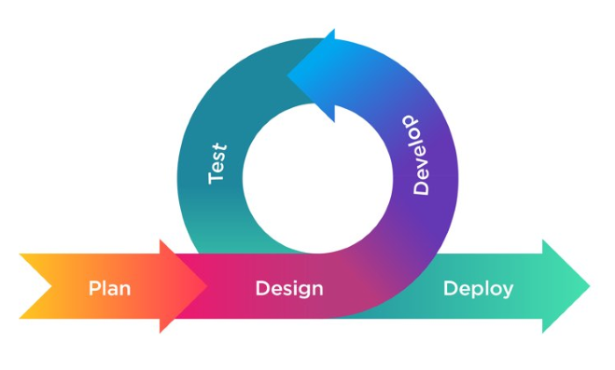*Agile Lean Methodology*

In developing the Mentor-Shift application, we adhere to Agile principles, focusing on flexibility and continuous improvement. Our approach encompasses five essential phases to streamline processes and maximize value. By following these phases, we aim to deliver a high-quality application that meets and evolves with user needs.

**Plan:** The planning phase in Agile methodologies focuses on creating a roadmap for the project. According to Behrens et al. (2021), Agile planning involves iterative cycles, frequent reassessment, and adaptability to change, this approach allows teams to respond quickly to changes and uncertainties in the project environment.

As our first step, we defined the core features and functionalities based on the needs and feedback of the users. We then designed a flexible project roadmap that helped us prioritize tasks according to the change in information and requirements. It was done iteratively so that we were always aligned with our goals but adaptable to any change.

**Design:** Agile design emphasizes collaboration and iterative improvement. Highsmith (2002) describes Agile design as a process where teams work closely with stakeholders to create designs that meet user needs. Design is continuously refined through regular feedback loops, ensuring the final product is both functional and user-friendly.

We held collaborative design sessions with teachers and learners to ask for their views during the iteration of the designs. We created wireframes and prototypes, which were then reviewed and changed based on feedback from beneficiaries. It contributed to our design being more user-friendly and meeting their needs.

**Develop:** In Agile development, the focus is on delivering working software frequently. Beck et al. (2001) highlight practices such as pair programming, test-driven development (TDD), and continuous integration to ensure high-quality code. Development is done in small, iterative cycles, allowing for constant feedback and improvements.

We implemented features on short sprints. Every iteration produced a functional increment of the app. This enabled us to incorporate user feedback quickly and update the app continuously.

**Test:** Testing in Agile is integrated throughout the development process. Crispin and Gregory (2009) emphasize the importance of continuous testing, where testing is done alongside development to catch defects early. Automated testing is also a key practice, ensuring that changes do not introduce new issues and maintaining software quality.

Throughout the development process, we are constantly testing it. We have implemented testing of the newly added functionalities, though the previous is not in any way affected because of early detection of faults helped us make corrections, resulting in high efficiency and software reliability.

**Deploy:** The deployment phase in Agile involves continuous delivery and integration. Humble and Farley (2010) describe deployment as an automated process that allows teams to release new features quickly and reliably. This approach ensures that the software is always in a deployable state, enabling frequent and incremental releases to users.

We're currently preparing for the deployment phase. This preparation will allow us to provide new features and updates to users more regularly and consistently in the future.

**Purpose, Deliverables, and Developmental Activities**

**Table 2.1**

*Activities of Agile Lean Methodology*

|  |  |  |  |
| --- | --- | --- | --- |
| **Method** | **Purpose** | **Deliverables** | **Development**  **Activities** |
| Plan | Create a roadmap for the project, prioritize tasks, and adapt to changes | Project roadmap, prioritized task list | Outline core features, gather user feedback, create flexible project roadmap, reassess and adjust plans |
| Design | Collaborate with stakeholders to create user-centric designs | Wireframes, prototypes, design documents | Conduct design sessions with educators and students, create and iterate on wireframes and prototypes based on feedback |
| Develop | Deliver working software frequently through iterative cycles | Functional increments of the app | Implement features in short sprints, use pair programming and TDD, integrate new code continuously, incorporate user feedback |
| Test | Ensure software quality and reliability through continuous testing | Test reports, defect logs | Conduct manual testing of new features, verify existing features remain unaffected, identify and correct defects early |
| Deploy | Prepare for continuous delivery and integration | Deployment plan | Prepare deployment process, ensure app is in a deployable state for future releases |

**DATA GATHERING TECHNIQUES**

The study employs in-depth interviews and surveys to investigate student and educator experiences, specifically focusing on learning styles and areas conducive to personalized learning. Its primary objective is to gain comprehensive insights into these experiences:

**Interviews.** Perform in-depth interviews with instructors, students, and leaders in education to learn about their perspectives on tutoring strategies, difficulties faced by students, and possible advantages of the Mentor-Shift app.

**Questionnaire.** Use online questionnaires to get numerical data from educators and students. Responses from the students will cover expectations, difficulties, and preferences for mobile learning and individualized tutoring. The opinions of educators will shed light on the methods of tutoring that are used today and what they anticipate from the Mentor-Shift app.

**Document Analysis.** Conduct document analysis using literature reviews and research studies to gather information already in the public domain about mobile learning, personalized tutoring, and the effectiveness of related educational technology applications from the perspectives of educators and students.

**SOURCES OF DATA**

The data-gathering methods the researchers focused on were interviews and research, wherein the participants in the interviews were mixed with DWCL students, faculty members, and educational leaders. Furthermore, the researchers review the literature and research studies that will assist them in gathering relevant information about personalized tutoring, mobile learning, and educational technology.

**Interviews.** Students of the SOECS department under IT, CS, and Engineering courses are interviewed to learn about their opinions on the difficulties facing tutoring today, what they hope to get out of the Mentor-Shift program, and what they think about individualized tutoring techniques. These interviews will yield insightful information about the particular requirements and expectations of students for academic help.

In order to learn about the difficulties faced by tutors, what they hope to gain from the Mentor-Shift program, and their thoughts on individualized tutoring techniques, faculty members are also interviewed. Their backgrounds in mentoring and teaching will provide insightful information about the viability and efficacy of the suggested program.

**Questionnaires.** Students as well as educators will receive surveys in order to collect data on demographics, preferred learning styles, technological aptitude, and suggestions for

future features for the Mentor-Shift app. The application will be developed and customized to match the unique needs and preferences of the target customers based on the quantitative insights this data will offer.

**Research.** A thorough assessment of the literature and research studies are carried out to obtain information and understanding regarding mobile learning, individualized tutoring, and educational technology applications. The present evaluation aims to integrate current research and optimal methodologies to provide guidance for the development and execution of the Mentor-Shift initiative, considering the viewpoints of educators and students alike.

**SURVEY RESULTS**

In this section, we present the findings and analysis derived from the survey conducted as part of our research project. The survey aimed to gather insights from both students and educators regarding their perspectives, experiences, and expectations related to the Mentor-Shift application.

Through comprehensive data collection and analysis, we illuminate key trends, preferences, and challenges identified by participants, offering valuable insights that inform the development and implementation of Mentor-Shift.

**Table 2.2.**

*Reasons Why Students Shift*

|  |  |
| --- | --- |
| **Survey Options** | **Results** |
| The course content was too difficult. | 11 (52.4%) |
| The course was not relevant to my career goals. | 8 (38%) |
| The course was too time-consuming. | 3 (14.3%) |
| The course did not provide enough hands-on experience. | 7 (33.3%) |
| The course was not offered during my preferred times. | 5 (23.8%) |
| The course was not offered in a location that was convenient for me. | 3 (14.3%) |
| The course was not being taught by a faculty member I liked or respected. | 2 (9.5%) |
| The course did not cover the topics I was interested in. | 6 (28.6%) |
| The course was too expensive. | 2 (9.5%) |

Table 2.2 provides insights into the reasons students consider shifting courses, as indicated by survey responses. Key reasons include course difficulty, lack of relevance to career goals, time constraints, inadequate hands-on experience, scheduling conflicts, inconvenient locations, faculty preferences, and dissatisfaction with course topics. These findings underscore the multifaceted factors influencing students' decisions to explore alternative academic paths, emphasizing the need for targeted interventions to support student retention and success.

**Table 2.3**

*Students Mindset Before Shifting*

|  |  |
| --- | --- |
| **Survey Options** | **Results (%)** |
| “Fear unknown: New course, scary!” | 5 (23.8%) |
| “Sunk costs: Invested time & money, can't waste it.” | 12 (57.1%) |
| “Limited options: Can't easily switch due to restrictions.” | 7 (33.3%) |
| “Fear failure: Don't want to seem like a quitter.” | 14 (66.6%) |
| “External pressure: Others expect me to stay the course.” | 9 (42.9%) |
| “Lack of support: Feel alone in considering the change.” | 6 (28.6%) |

Table 2.3 presents key factors influencing students' decisions to shift courses, including fear of the unknown, sunk costs, limited options, fear of failure, external pressures, and

lack of support. The free-text response highlights confusion as an additional concern. These findings emphasize the nuanced considerations students weigh when contemplating course changes, underscoring the need for comprehensive support mechanisms to address diverse challenges.

**Table 2.4.**

*Students Wish They Had Personalized Guidance and Support*

|  |  |
| --- | --- |
| **Survey Options** | **Results** |
| Always | 8 (38.1%) |
| Often | 6 (28.6&) |
| Sometimes | 5 (23.8%) |
| Rarely | 2 (9.5%) |
| Never | 0 |

Table 2.4 illustrates students' preferences regarding personalized guidance and support. Results show varying degrees of frequency, with some students expressing a consistent desire for support ("Always"), while others indicate occasional needs ("Often," "Sometimes"). A smaller percentage reports infrequent requirements ("Rarely"), and some indicate no need for personalized support ("Never"). These findings highlight the diverse and evolving support needs of students, emphasizing the importance of flexible and adaptable support structures within educational environments. By understanding these varying needs, institutions can better tailor their mentorship programs to provide more targeted and effective guidance, ensuring that each student receives the appropriate level of support based on their individual requirements. This approach not only enhances student engagement but also fosters a more personalized and responsive learning experience, contributing to overall academic success and satisfaction.

**Table 2.5.**

*Biggest Obstacle Faced in Seeking Academic Help*

|  |  |
| --- | --- |
| **Survey Options** | **Results** |
| Difficulty finding mentors with relevant expertise | 4 (19%) |
| Traditional tutoring services being too expensive | 0 |
| Time constraints making scheduling sessions difficult | 2 (9.5%) |
| Feeling uncomfortable asking for help | 15 (71.4%) |

Table 2.5 outlines the main obstacles students face when seeking academic help, including difficulty finding relevant mentors, financial constraints, scheduling conflicts, and discomfort in asking for assistance. These results underscore the multifaceted challenges students encounter in accessing support services, highlighting the need for accessible and affordable resources to address diverse needs effectively.

**Table 2.6.**

*Importance of Connecting with Mentors using Mobile App*

|  |  |  |  |  |  |
| --- | --- | --- | --- | --- | --- |
|  | **Not Important At All** | **Slightly Important** | **Moderately Important** | **Very Important** | **Extremely Important** |
| **Scale** | **1** | **2** | **3** | **4** | **5** |
| **%** | 0 | 0 | 4 (19%) | 10 (47.6%) | 7 (33.3%) |

Table 2.6 illustrates the importance students attribute to connecting with mentors via a mobile app, rated on a linear scale from "Not Very Important At All" to "Very Important." These responses offer insights into students' preferences and expectations regarding the accessibility

and convenience of mobile platforms for mentorship, guiding the development of "Mentor-Shift" to meet their needs effectively.

**Table 2.7**

*Students Interested In Using The Propose App*

|  |  |
| --- | --- |
| **Survey Options** | **Results** |
| Yes, definitely | 76.2 % |
| Maybe, depending on the features | 23.8 % |
| No, I prefer traditional tutoring methods | 0 |

Table 2.7 shows students' interest in utilizing "Mentor-Shift" for personalized or academic help, offering options like "Yes, definitely," "Maybe, depending on features," and "No, preferring traditional tutoring methods." This format allows respondents to express their inclination toward the proposed app, reflecting their openness to innovative learning platforms versus traditional methods.

**Table 2.8**

*Features Preferred By Students*

|  |  |
| --- | --- |
| **Survey Options** | **Results** |
| Real-time communication tools for instant feedback | 11 (52.4%) |
| Ratings and review system for mentors | 11 (52.4%) |
| Ability to share notes and resources with mentors | 14 (66.7%) |
| Peer-to-peer tutoring options | 9 (42.9%) |
| Customizable notifications for session reminders and updates | 7 (33.3%) |
| Options for virtual office hours with mentors | 10 (47.6%) |
| Personalized Learning Paths | 10 (47.6%) |

Table 2.8 outlines students' preferred features for the "Mentor-Shift" app, including real-time communication, mentor ratings, resource sharing, peer-to-peer tutoring, customizable notifications, virtual office hours, and personalized learning paths. This data informs the development of the app to align with students' preferences for enhancing their mentoring experience digitally.

|  |  |  |  |
| --- | --- | --- | --- |
| **Participant** | **Obstacles Encountered in Academics** | **Challenges in Course Material/ Task Comprehension** | **Having Mentor Support through Academic Challenges?** |
| 1 | 20% | 30% | 50% |
| 2 | 40% | 60% | 100% |
| 3 | 20% | 20% | 60% |
| 4 | 20% | 40% | 80% |
| 5 | 20% | 40% | 100% |

|  |  |  |
| --- | --- | --- |
| **Participant** | **Having a Mentor who can help in which areas he/she can assist** | **Mentoring Impact** |
| 1 | 100% | 100% |
| 2 | 100% | 100% |
| 3 | 100% | 100% |
| 4 | 100% | 100% |

|  |  |  |
| --- | --- | --- |
| 5 | 100% | 100% |

The purpose of the student survey is to identify academic obstacles and evaluate how well mentoring addresses them. It examines a few challenges, including time management, comprehending the readings, and staying motivated. By being aware of these obstacles, teachers can modify mentorship programs to better fit the requirements of their students and improve their educational experiences. Students' opinions on how mentors may support them during difficult times and offer educational guidance are also gathered through the survey. All things considered, it is an indispensable instrument for molding fruitful mentorship programs in academic environments.

**Table 2.9**

*Common Challenge Students Face According to Educators*

|  |  |
| --- | --- |
| **Survey Options** | **Results** |
| Understanding complex concepts | 7 (43.8%) |
| Time management and workload | 6 (37.5%) |
| Lack of resources or support | 2 (12.5%) |
| Students just being lazy and relying on AI | 1 (6.3%) |

Table 2.9 outlines educators' views on common student challenges, including complex concepts, time management, resource limitations, and reliance on AI. These insights inform the development of supportive strategies in the "Mentor-Shift" platform to address student difficulties effectively.

**Table 2.10**

*Ways Personalized Assistance Can Impact A Student’s Academic Success and Learning Experience*

|  |  |
| --- | --- |
| **Survey Options** | **Results** |
| Providing tailored explanations and assistance | 4 (25%) |
| Building confidence and motivation | 5 (31.3%) |
| Fostering a supportive learning  environment | 6 (37.5%) |
| All of the above | 1 (6.3%) |

Table 2.10 summarizes educators' perspectives on the impact of personalized assistance on student success, including tailored support, confidence-building, and fostering a supportive environment. These insights guide feature development in the "Mentor-Shift" app, aligning with educators' views to enhance student learning experiences effectively.

**Table 2.11**

*Important Skills For Students To Develop In Their Field*

|  |  |
| --- | --- |
| **Survey Options** | **Results** |

|  |  |
| --- | --- |
| Technical skills | 2 (12.5%) |
| Problem-solving abilities | 3 (18.8%) |
| Critical thinking skills | 6 (37.5%) |
| All of the above | 5 (31.2%) |

Table 2.11 outlines educators' views on vital student skills, including technical expertise, problem-solving, and critical thinking. These insights inform the development of features within the "Mentor-Shift" app to bolster student proficiency in these areas, aligning platform offerings with educators' input to enhance academic and professional success.

**Table 2.12**

*Educators Comfortability In Using Mobile Apps For Helping, Connecting, and Supporting Students*

|  |  |  |  |  |  |
| --- | --- | --- | --- | --- | --- |
|  | **Not Comfortable At All** | **Slightly Comfortable** | **Moderately Comfortable** | **Very Comfortable** | **Extremely Comfortable** |
| **Scale** | **1** | **2** | **3** | **4** | **5** |
| **%** | 0 | 0 | 3 (18.8%) | 7 (43.8%) | 6 (37.5%) |

Table 2.12 gauges educators' comfort using mobile apps for mentorship on a scale from "Not Very Comfortable" to "Very Comfortable." This insight informs strategies to support mentors' adoption of the "Mentor-Shift" app, enhancing its usability and effectiveness.

**Table 2.13**

*Educators Belief in Apps For Improving And Enhancing Student’s Knowledge*

|  |  |
| --- | --- |
| **Survey Options** | **Results** |
| Yes | 12 (75%) |
| No | 0 |
| Maybe | 4 (25%) |

Table 2.13 displays survey responses from educators and mentors regarding the effectiveness of a mentoring app in enhancing students' knowledge retention and motivation, potentially reducing course shifting or dropping out. Response options include "Yes," "No," and "Maybe," offering insights into educators' perceptions of the app's utility for supporting student success. This question directly assesses the app's potential impact on addressing student needs and retention challenges, guiding app development and implementation strategies.

**Table 2.14**

*Features Preferred By Educators For The App*

|  |  |
| --- | --- |
| **Survey Options** | **Results** |
| Real-time messaging and communication | 41.7 % |
| Personalized learning plans | 41.7 % |

|  |  |
| --- | --- |
| Progress tracking and analytics | 91.7 % |

Table 2.14 presents educators' preferences for features in the "Mentor-Shift" app, including options such as technical skills, problem-solving abilities, critical thinking skills, and an option for selecting all of the above. These choices reflect educators' priorities in fostering students' proficiency in key areas essential for academic and professional success.

**THEORETICAL FRAMEWORK**

## Figure 2.2

*Community of Inquiry (CoI) Framework Garrison, Anderson & Archer (2000, 2001)*

**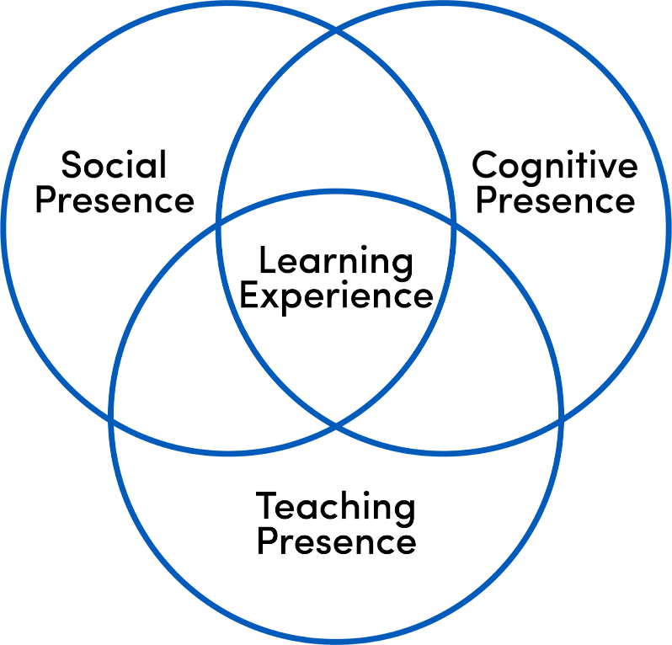**

The proposed solution is based on the Community of Inquiry (CoI) framework, which focuses on three key elements: cognitive presence, social presence, and teaching presence. The Mentor-Shift app aims to foster deep learning and meaningful interactions between mentors and mentees by leveraging these elements.

Online learning can be enhanced by the convergence of mentorship-based application and the Community of Inquiry (CoI) framework. In particular, this concerns the improvement of the quality of relationships between mentors and mentees. According to the CoI conceptual model, there are three critical presences, namely cognitive, social, and teaching, which are essential for effective online learning. Teaching presence refers to the involvement of the mentor in course creation, organized help, and helpful criticism among online mentorship. (Zhang et al., 2021.)

The structured interactions in the CoI model reduce the student isolation and increase student retention as long as mentors take their mentees through course concept application to real life settings. The educational experience improves for such students (TOPkit, 2023). This way, through the creation of a rich online environment where a mentor assists the mentee to move forward and monitor how he or she can take charge of his learning and, as has been realized with other mentorship models, improve learning performance, MentorShift can benefit from the CoI.

**CONCEPTUAL FRAMEWORK**

**Figure 2.3**

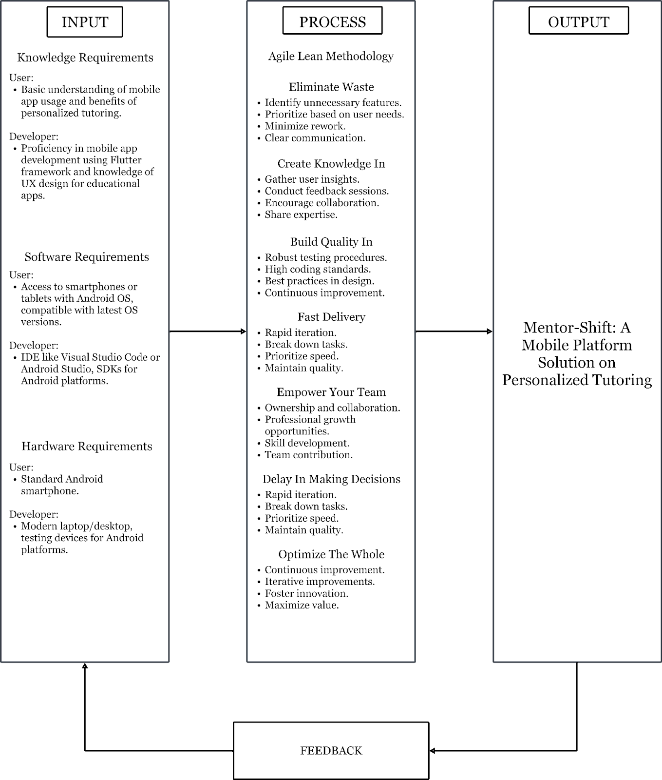*Conceptual Framework of the Proposed System*

The project's conceptual architecture outlines essential information and resources for both users and developers. Users are expected to have a basic understanding of mobile apps and the benefits of individualized teaching, while developers require a broader skill set encompassing expertise in programming languages such as Java & Kotlin, proficiency in mobile app development frameworks like Android Gradle, and knowledge of user experience design principles. Additionally, developers must possess familiarity with database management systems for secure data storage and software testing procedures for app debugging and optimization.

The process of each phase utilizes the Agile Lean methodology, which encompasses the seven phases of the Agile Lean methodology: Eliminate Waste, Create Knowledge In, Build Quality In, Fast Delivery, Empower Your Team, Delay in Making Decisions, and Optimize the Whole. Each phase is guided by specific objectives aimed at influencing the progression of the Mentor-Shift app in alignment with educational goals and user needs. From defining system requirements and designing user interfaces to app development, testing, and deployment, the process segment ensures a disciplined and systematic approach to achieving the desired mobile application outcome. Through these phases, the conceptual framework acts as a roadmap for the seamless development and deployment of the Mentor-Shift app, with the aim of revolutionizing individualized tutoring experiences for students in the School of Engineering and Computer Studies.

**Chapter 3**

**REQUIREMENTS ANALYSIS AND DOCUMENTATION**

The requirements analysis and documentation presented the figures of the flowchart, system architecture, software design, namely, the use case, class, and sequence diagrams. It also includes tables for database design, system requirements, system tradeoffs, system design, project timeline, and statistical tools.

**FLOWCHART**

**Figure 3.1**

**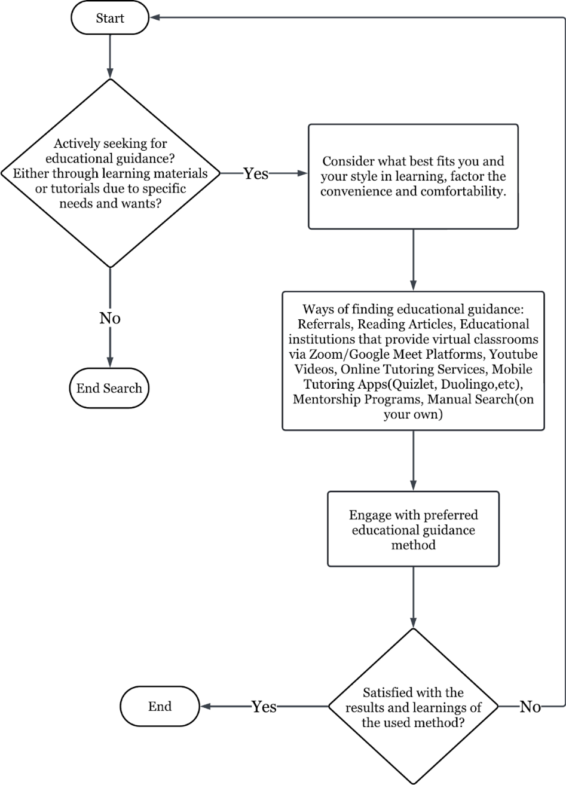***Flowchart of the Manual Process*

For individuals seeking tutoring or mentoring support, their preferred means can significantly impact their learning experience. If immediate assistance and interaction are crucial, education institutions offering virtual classrooms via platforms like Zoom and Google Meet provide real-time engagement opportunities, fostering active learning environments. Those who favor visual and multimedia learning formats can benefit from accessing YouTube tutorials, which cater to diverse academic demands through engaging video content. Online directories for tutors or mentors are ideal for those actively searching for personalized assistance in their field, providing access to a wide range of expertise through online tutoring services.

For learners who prefer studying independently on mobile devices, mobile tutoring apps such as Quizlet and Duolingo offer convenient access to educational resources tailored to individual learning styles. These platforms also often include gamified learning features, enabling users to track progress and stay motivated. Meanwhile, individuals interested in formal mentoring programs can explore dedicated mentorship platforms that provide structured guidance, pairing learners with experienced professionals in their field of interest. Additionally, some learners may prefer social learning communities where they can collaborate with peers and mentors in group settings, fostering a more collective and interactive approach.

Finally, for those who prefer a more traditional approach, manual searching for tutors and mentors in person remains a viable option, allowing for direct interactions and personalized connections within local communities. Depending on their unique preferences and needs, individuals can select the most suitable means of accessing tutoring or mentoring support to enhance their learning journey, whether through real-time virtual engagement, multimedia platforms, or personal face-to-face interactions.

**SYSTEM ARCHITECTURE**

**Figure 3.2**

*System Architecture of the Proposed System*

**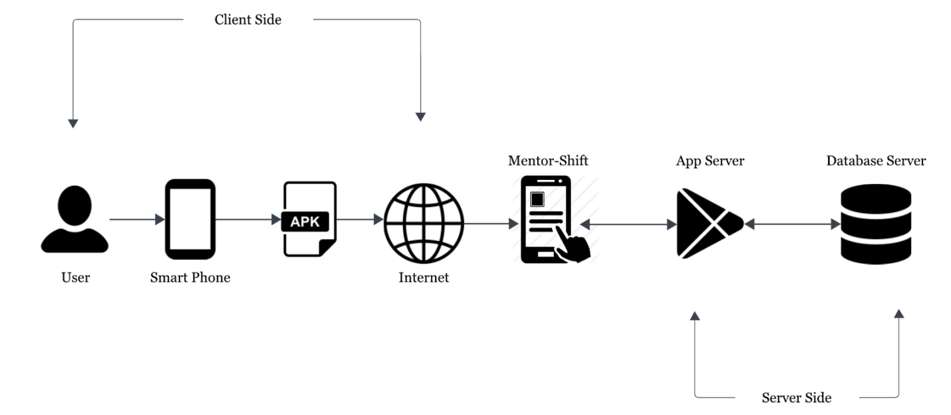**

The system architecture for the app is made to meet the precise needs and goals listed in the project scope. Because of the architecture's modular and scalable design, it may be easily expanded upon and modified in the future. We hope to create seamless communication and interaction between users and the system by utilizing a client-server approach, where a mobile application acts as the client interface and a cloud-based server handles the fundamental processing and data management activities. Reliability, security, and performance are given top priority in the architecture, which includes features like load balancing, encryption protocols, and redundant server instances to guarantee high availability, data integrity, and ideal system responsiveness.

**SOFTWARE DESIGN**

The software design for the Mentor-Shift application focuses on creating a user-friendly platform for students and mentors. It encompasses architecture, components, interfaces, and data to support effective mentorship. Key considerations include scalability, security, and ease of use, ensuring the application performs reliably and efficiently as the user base grows.

**Figure 3.3**

*Use-Case Diagram*

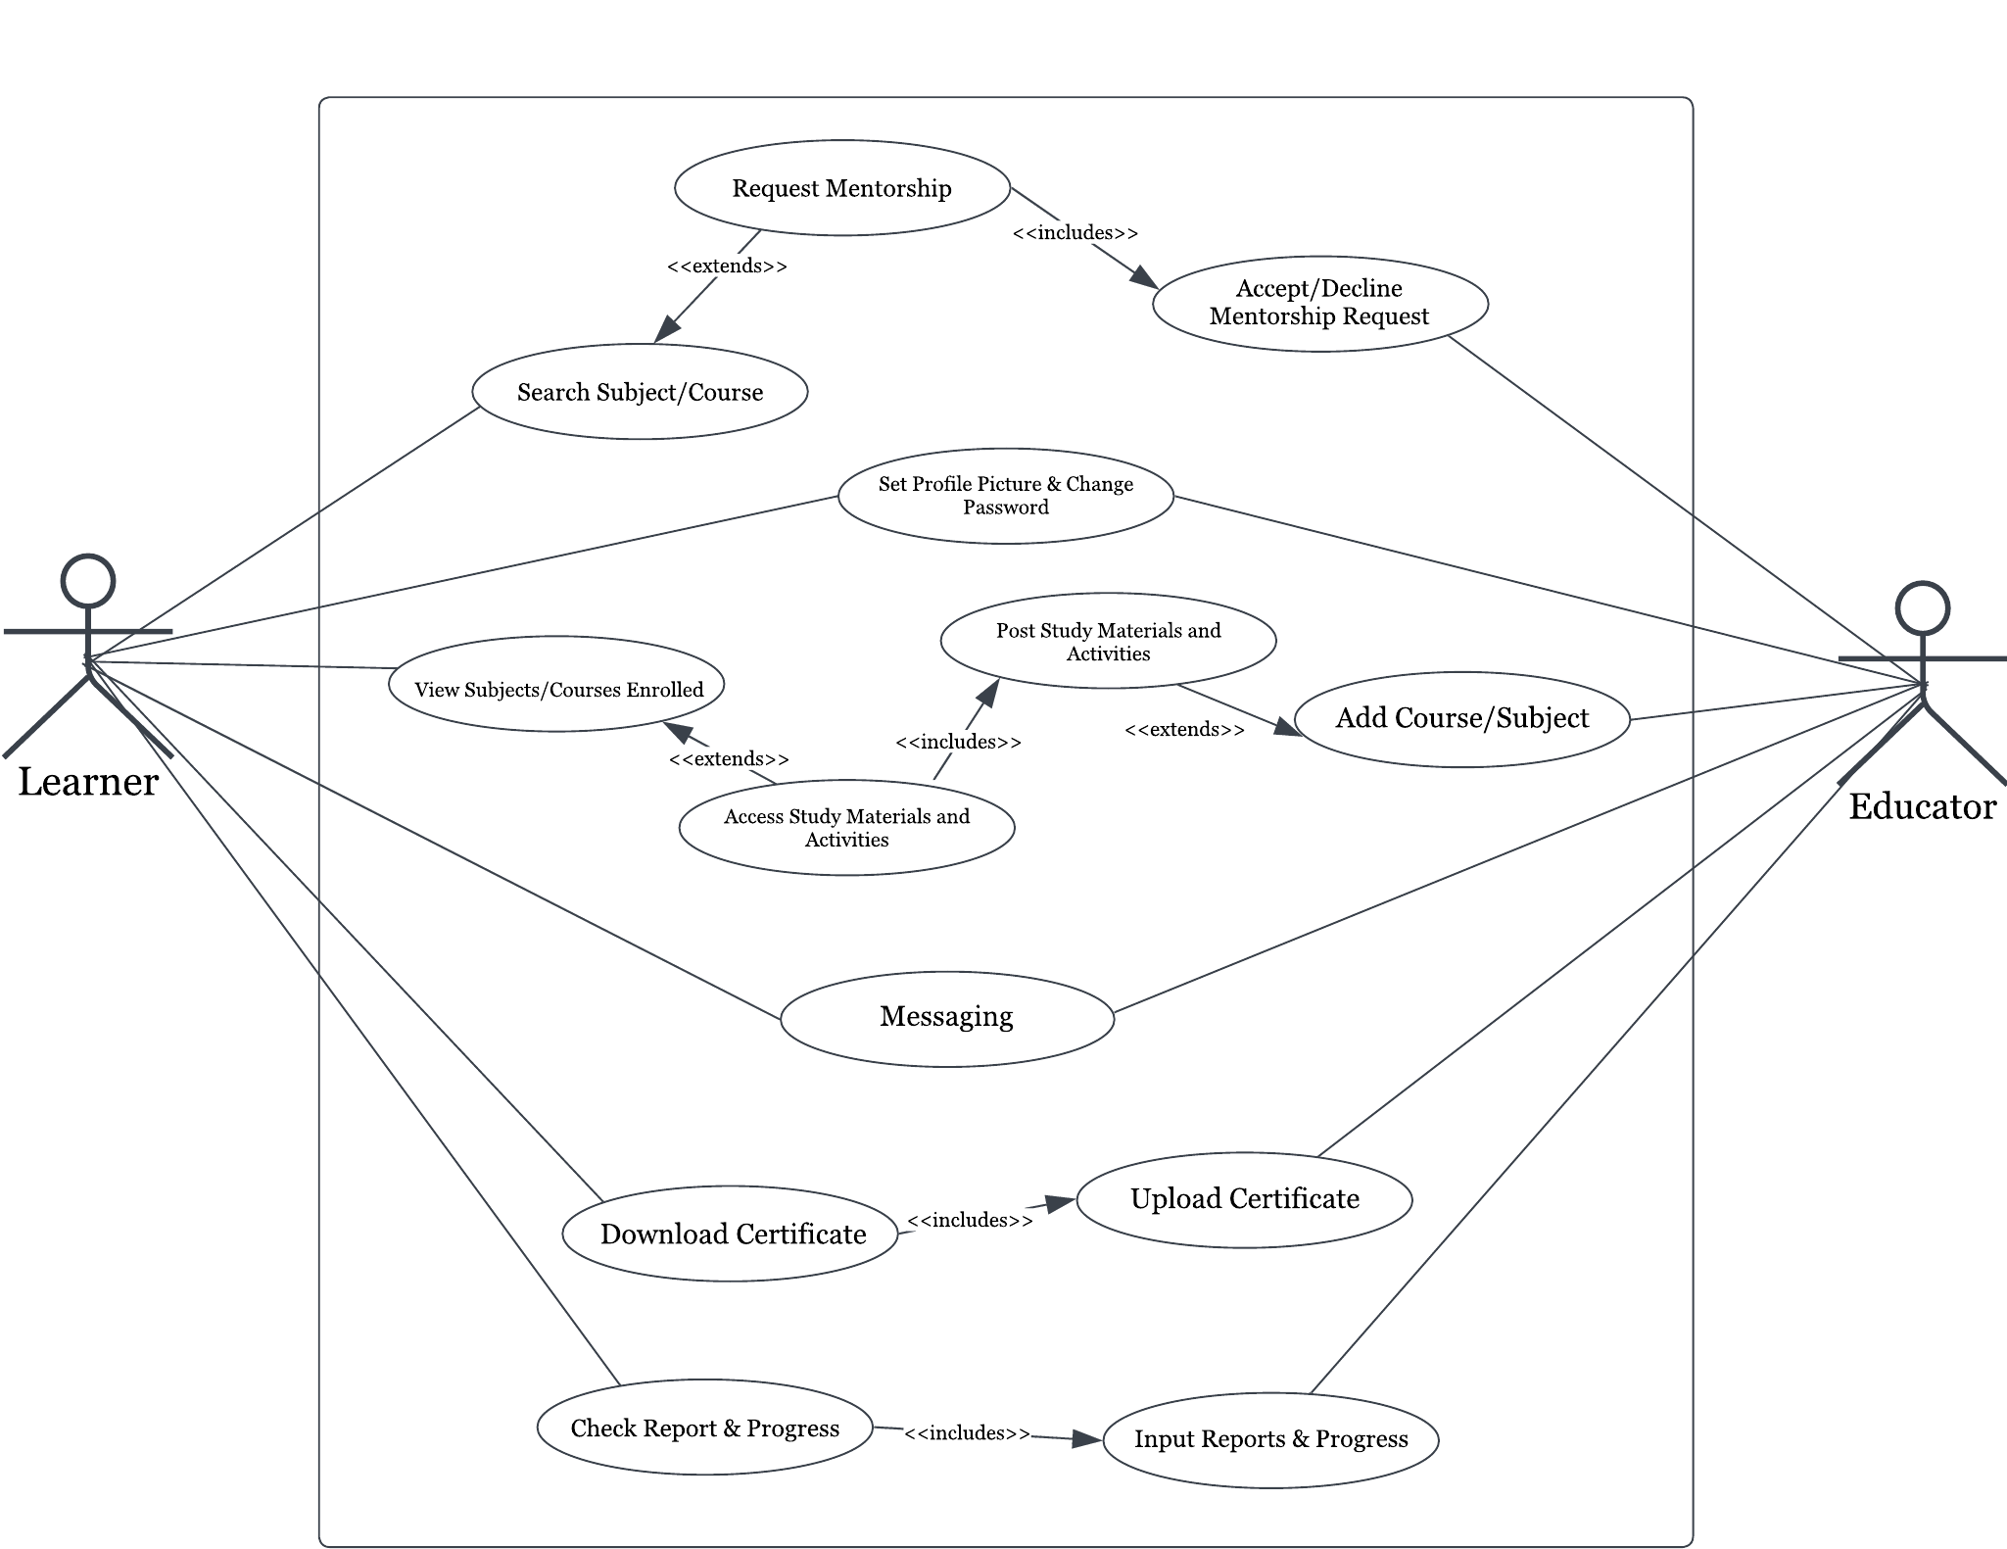

The use-case diagram for the Mentor-Shift app features two primary user types: Learner and Educator. Learners can search for subjects or courses and request mentorship, with educators having the final say to accept or decline these requests. Learners can manage their profiles by setting a profile picture and changing their password, view enrolled subjects, and access study materials and activities posted by their educators. They can also message educators, download certificates once uploaded, and check their reports and progress, which are defined by the educator.

Educators can review and either accept or decline mentorship requests from learners, manage their profiles, add new courses or subjects, and post relevant study materials and activities. They can also communicate with learners through messaging, upload certificates for completed tasks, and input and update reports and progress for each learner.

**Figure 3.4**

**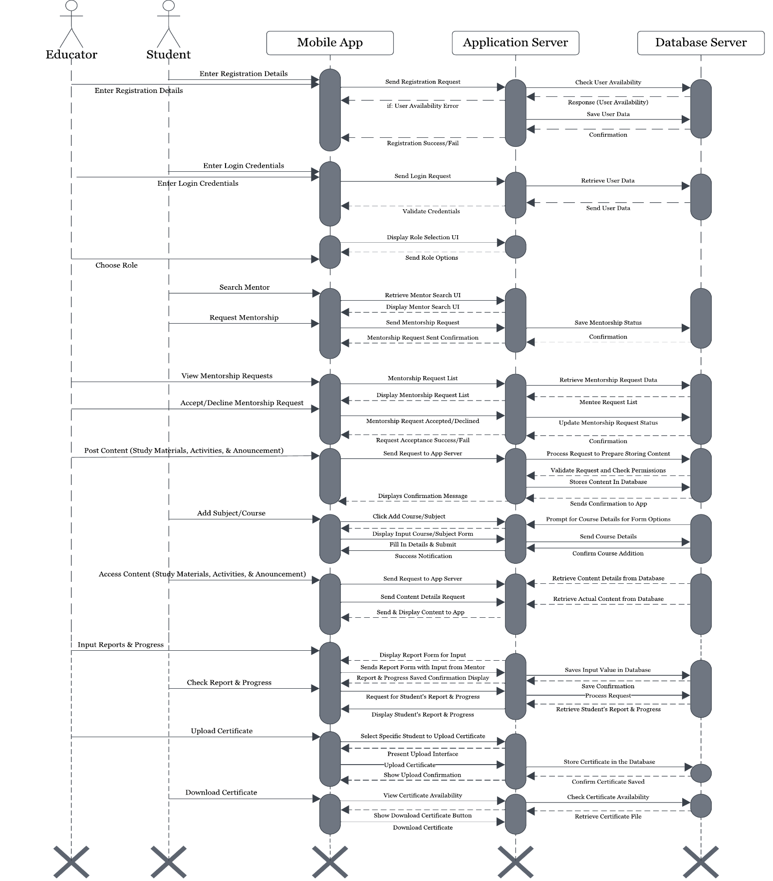***Sequence Diagram*

The sequence diagram for the "Mentor-Shift" mobile app illustrates a range of key functionalities for smooth user interaction, providing an efficient platform for both educators and students. Both educators and students can choose their respective roles upon registration or login, using their credentials based on the role they selected. Students can search for mentors by browsing profiles that match their academic needs and request mentorship from the educator of their choice. Once a request is sent, educators can review, accept, or decline these mentorship requests, enabling a personalized mentorship process.

Educators play a central role in managing the academic journey of their mentees. They can post study materials, activities, quizzes, and assignments via URL links, which are accessible to students after their mentorship request has been approved. Furthermore, educators can make important announcements to keep students updated on deadlines, new content, or upcoming events. As students engage with these resources, educators can monitor their progress, inputting reports and scores for completed activities. These reports provide valuable insights for students to track their academic development.

The app facilitates certification by allowing educators to upload certificates for specific students who have successfully completed their tasks. Once a certificate is uploaded, students can view and download it, giving them tangible proof of their achievements and milestones.

The app supports course management by enabling educators to add new courses or subjects. Educators can initiate the process by selecting the "Add Course" option in their dashboard, entering the required course details, and submitting the information. The app then verifies and stores these details in the course management system, making the new course available for student enrollment.

This sequence diagram captures the critical interactions and features that make Mentor-Shift a dynamic tool for enhancing mentorship and education through streamlined processes and real-time collaboration between students and educators.

**Figure 3.5**

*Class Diagram*

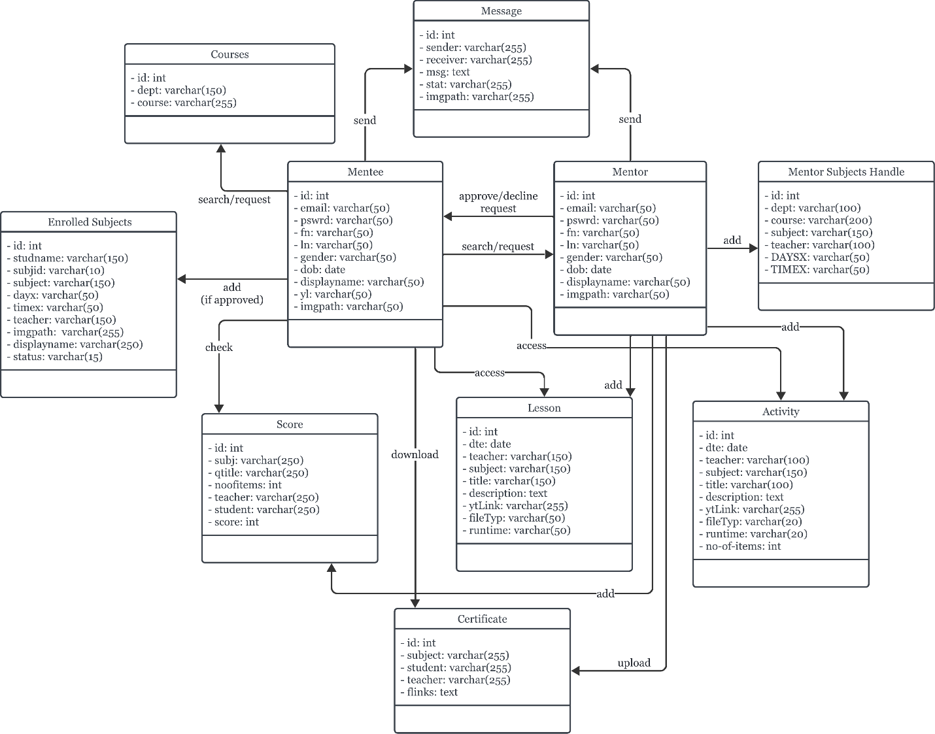

The class diagram depicts the interaction between Mentee and Mentor. Aside from selecting courses, mentees can also message mentors, look for mentors, and ask for mentorship. The chosen course is added to their enrolled subjects after it is approved, enabling them to view lessons and activities, download certificates, and check their scores. Based on their area of expertise, mentors can upload lessons, activities, and certificates, send messages, accept or reject mentorship requests, and add courses. The diagram illustrates how mentees can access courses and learning resources provided by mentors once their mentorship approval is granted.

**DATABASE DESIGN**

The tables below represent the foundational database structure for users and mentors within the Mentor-Shift application. The User table stores essential information about each user, while the Mentor table extends the user information with specific details related to mentors' expertise and availability.

**Table 3.1**

*Mentee Table*

|  |  |  |  |  |  |  |
| --- | --- | --- | --- | --- | --- | --- |
| id(PK) | email | last\_name | first\_name | gender | displayname | imgpath |
| birthday | password | yearlvl |  |  |  |  |

Table 3.1 outlines the Mentee Table, which stores essential information about students in the Mentor-Shift app. Each mentee is identified by a unique id (primary key) and includes fields such as email, first\_name, last\_name, gender, birthday, and yearlvl to track personal and academic details. The displayname and imgpath fields manage the mentee's public profile, while password ensures secure login. This table is crucial for organizing mentee profiles and facilitating personalized mentorship within the app.

**Table 3.2**

*Mentor Table*

|  |  |  |  |  |  |  |
| --- | --- | --- | --- | --- | --- | --- |
| id(PK) | email | last\_name | first\_name | gender | displayname | imgpath |
| birthday | password |  |  |  |  |  |

Table 3.2 details the Mentor Table, which holds key information for mentors in the Mentor-Shift app. Each mentor is uniquely identified by the id (primary key) and includes fields such as email, first\_name, last\_name, gender, and birthday for personal and demographic information. The displayname and imgpath fields manage the mentor's public profile, while password ensures secure access. This table is fundamental for organizing mentor profiles, enabling efficient mentor-mentee interactions within the app.

**Table 3.3**

*Mentor Subject Handle*

|  |  |  |  |  |  |  |
| --- | --- | --- | --- | --- | --- | --- |
| id(PK) | dept | course | subject | teacher | days | time |

Table 3.3 presents the Mentor Subject Handle, which manages the subjects and schedules associated with mentors in the Mentor-Shift app. Each entry is identified by a unique id (primary key) and includes fields such as dept (department), course, subject, and teacher, providing detailed information about the subjects offered by each mentor. Additionally, the days and time fields specify when the subjects are available, allowing mentees to plan their schedules effectively. This table plays a crucial role in linking mentors with their respective subjects, facilitating organized and accessible mentoring sessions.

**Table 3.4**

*Activity Table*

|  |  |  |  |  |  |  |
| --- | --- | --- | --- | --- | --- | --- |
| id(PK) | date | teacher | subject | title | description | ytlink |
| filetype | runtime | no-of-items |  |  |  |  |

Table 3.4 outlines the Activity Table, which catalogs educational activities within the Mentor-Shift app. Each activity is identified by a unique id (primary key) and includes fields such as date, teacher, and subject to provide context for the activity. The title and description fields summarize the activity's content, while the ytlink field allows for the inclusion of related YouTube videos. The filetype indicates the format of any associated materials, and runtime specifies the duration of the activity. Lastly, no-of-items represents the number of resources included. This table is crucial for managing structured learning experiences for mentees.

**Table 3.5**

*Certificate Table*

|  |  |  |  |  |
| --- | --- | --- | --- | --- |
| id(PK) | subject | student | teacher | flinks |

Table 3.5 presents the Certificate Table, which stores information related to the certificates awarded within the Mentor-Shift app. Each certificate is identified by a unique id (primary key) and includes fields such as subject and student to indicate the area of achievement and the recipient of the certificate. The teacher field denotes the mentor who issued the certificate, while flinks provides links to access the certificate files. This table is essential for tracking and managing the certification process, ensuring that mentees receive proper recognition for their accomplishments.

**Table 3.6**

*Courses Table*

|  |  |  |
| --- | --- | --- |
| id(PK) | dept | course |

Table 3.6 details the Courses Table, which organizes information about the various courses available within the Mentor-Shift app. Each course is uniquely identified by an id (primary key) and includes fields such as dept (department) and course, providing clarity on the academic structure and categorization of each course. This table is vital for facilitating the selection of courses by both mentors and mentees, ensuring that users can easily navigate the educational offerings available within the app.

**Table 3.7**

*Enrolled Subjects Table*

|  |  |  |  |  |  |  |
| --- | --- | --- | --- | --- | --- | --- |
| id(PK) | studentName | subjectId | subject | days | time | teacher |
| imgpath | displayname | status |  |  |  |  |

Table 3.7 presents the Enrolled Subjects Table, which tracks the subjects that students are enrolled in within the Mentor-Shift app. Each entry is uniquely identified by an id (primary key) and includes fields such as studentName and subjectId to link students with their respective subjects. Additional fields like subject, days, and time provide details on the scheduling of each enrolled subject, while teacher identifies the mentor associated with the subject. The imgpath and displayname fields enhance the student’s profile representation. Lastly, the status field indicates the current enrollment status of the student. This table is crucial for managing student enrollments and ensuring efficient tracking of academic participation.

**Table 3.8**

*Lessons Table*

|  |  |  |  |  |  |  |
| --- | --- | --- | --- | --- | --- | --- |
| id(PK) | date | teacher | subject | title | descriptions | ytlink |
| filetype | runtime |  |  |  |  |  |

Table 3.8 outlines the Lessons Table, which organizes the instructional lessons available within the Mentor-Shift app. Each lesson is uniquely identified by an id (primary key) and includes fields such as date, teacher, and subject to provide context about the lesson's timing and content area. The title and description fields summarize the lesson's focus, while the ytlink allows for the inclusion of related YouTube videos. The filetype field specifies the format of any associated lesson materials, and runtime indicates the expected duration of the lesson. This table is essential for managing and delivering structured lessons, enhancing the educational experience for mentees.

**Table 3.9**

*Message Table*

|  |  |  |  |  |  |
| --- | --- | --- | --- | --- | --- |
| id(PK) | sender | receiver | message | status | imgpath |

Table 3.9 presents the Message Table, which captures the communication between users within the Mentor-Shift app. Each message is uniquely identified by an id (primary key) and includes fields such as sender and receiver to indicate the participants in the conversation. The message field contains the content of the communication, while the status field tracks whether the message has been sent, delivered, or read. The imgpath field can store any associated images or attachments related to the message. This table is essential for facilitating real-time

interactions between mentors and mentees, enhancing collaboration and support throughout the learning journey.

**Table 3.10**

*Score Table*

|  |  |  |  |  |  |  |
| --- | --- | --- | --- | --- | --- | --- |
| id(PK) | subject | quiz-title | no-of-item | teacher | student | score |

Table 3.10 details the Score Table, which records the assessment results for students within the Mentor-Shift app. Each entry is uniquely identified by an id (primary key) and includes fields such as subject and quiz title to specify the relevant assessment context. The no-of-items field indicates the number of questions or tasks included in the quiz. Additionally, teacher identifies the mentor responsible for administering the quiz, while student links the score to the specific learner. The score field captures the student's performance, providing a clear record of their achievements in various assessments. This table is crucial for tracking student progress and facilitating feedback on their learning outcomes.

**SYSTEM REQUIREMENTS**

These are basic rules that define the necessary functionalities and performance standards for a software project. They serve as a guide for developers, ensuring that the final product fits user requirements and business objectives. In this article, we will look at the exact system requirements for the proposed project, concentrating on important issues like functionality, usability, and security.

**Hardware Requirements**

Hardware requirements play a crucial role in determining the infrastructure needed to support its functionality and performance. These requirements encompass the server hardware specifications necessary to host the application, as well as the client hardware specifications required for users to access the app seamlessly on their mobile devices. By identifying and complying with these hardware requirements, developers can ensure that the Mentor-Shift app operates efficiently and delivers a smooth user experience to its users.

**Table 3.10**

*Server Hardware Requirements*

**Recommended Server Hardware Specifications**

|  |  |
| --- | --- |
| **Required Hardware** | **Specifications** |
| **Server** |  |
| OS | Windows 10 or higher/Linux-based operating system (e.g., Ubuntu Server) |
| CPU | AMD Ryzen 3 or higher |
| Disk | SSD storage (100 GB minimum) |
| Transfer | Gigabit Ethernet or higher |

**Table 3.11**

*Client Hardware Requirements*

**Recommended Client Hardware Specifications**

|  |  |
| --- | --- |
| **Required Hardware** | **Specifications** |
| **Client** |  |
| Processor | Qualcomm Snapdragon series for Android devices |
| Hard Disk Drive | 64 GB of internal storage |
| Memory | 3 GB RAM |
| Internet Bandwidth | 5 mbps |
| Devices | Android |

The recommended server hardware specifications for the app include a choice of operating system between Windows 10 or higher and Linux-based systems such as Ubuntu Server. This flexibility caters to different hosting preferences and environments. In terms of CPU, an AMD Ryzen 3 or equivalent processor is recommended to ensure efficient handling of server-side operations and requests. SSD storage with a minimum capacity of 100 GB is advised to support fast data access and retrieval, enhancing overall server performance. Having a Gigabit Ethernet or higher transfer rate is recommended to help smooth communication and data exchange between the server and client devices.

On the client side, the recommended hardware specifications focus on ensuring optimal performance and user experience for mobile users. For Android devices, processors from the Qualcomm Snapdragon series are recommended, while Apple A-series processors are recommended for iOS devices. A minimum of 64 GB of internal storage allows users to store app data and multimedia files without encountering storage limitations. With 3 GB of RAM, users can expect smooth multitasking and app operation on their devices. A stable internet connection with a bandwidth of at least 5 Mbps ensures reliable data transmission between the client device and the server, supporting real-time interactions and content delivery. The Mentor-Shift app is compatible with both Android and iOS devices, offering accessibility to a wide range of users across different mobile platforms.

**Software Requirements**

Specific software requirements are essential to ensure its functionality, security, and user experience. These requirements encompass the technologies, frameworks, programming languages, and development tools needed to build and deploy the application successfully. Following these software specifications, developers can produce a stable and intuitive platform that fulfills the requirements of mentors and mentees in the academic community.

**Table 3.12**

*Recommended Software Specifications*

**Recommended Software Specifications**

|  |  |
| --- | --- |
| **Particulars** | **Specifications** |
| Language | Java & Kotlin |
| Framework | Android Gradle |
| Database | MySQL |

The recommended software specifications for the Mentor-Shift app include Java and Kotlin as the programming languages for their robust performance and compatibility with Android development. The app will be built using the Android Gradle framework, which provides efficient project management and seamless integration with Android tools. MySQL will be used as the database solution, offering reliable data storage and online hosting capabilities, ensuring scalable data management, session handling, and smooth user interactions. This combination enables secure and efficient management of user data, notifications, and real-time information within the app.

**SYSTEM TRADEOFFS**

In this section, we explore the various compromises and decisions made during the development of the Mentor-Shift app. These tradeoffs involve balancing competing priorities such as functionality, performance, cost, and time-to-market. By carefully considering these tradeoffs, we aim to optimize the app's design and implementation to meet the needs of users while staying within resource constraints and project timelines.

**Table 3.13**

*Technical Issues*

|  |  |
| --- | --- |
| **Technical Issues** | **Trade Offs** |

|  |  |
| --- | --- |
| Performances | Mobile device speed should be at least 2.05 GHz. |
| Deployment | Android phone version 11 or higher |
| Operational Characteristics | To develop in a desktop computer with Windows 11 as its OS and AMD Ryzen 3 Mobile 3200G as its processor |
| Interoperability with Other Technologies | Can be developed with Android Studio as IDE, Android Studio’s Virtual Device Manager (VDM) for testing, Java & Kotlin as programming language, Git for version control, and MySQL as the database |

To ensure smooth development for the proposed app, a few technical issues should first be addressed.

Performance requirements necessitate a mobile device with a minimum speed of 2.05 GHz to ensure smooth operation of the app. While this ensures an optimal user experience, it may limit the app's compatibility with older or less powerful devices. Deployment considerations mandate that the app is compatible with Android phone version 11 or higher, which may restrict the user base to those with different devices or operating systems. Operational characteristics dictate development on a desktop computer running Windows 11 with an AMD Ryzen 3 Mobile 3200G processor, potentially limiting the development environment options for developers. Prioritizing interoperability with other technologies facilitates development using Android Studio as the IDE, Android Studio’s Virtual Device Manager for testing, Java & Kotlin as the programming language, Git for version control, and MySQL as database. While this ensures seamless integration and collaboration among development tools and services, it may restrict developers who prefer alternative tools or platforms. Thus, these tradeoffs highlight the need for careful consideration to balance technical requirements with practical considerations and developer preferences.

**Table 3.14**

*Operational Issues*

|  |  |
| --- | --- |
| **Operational Issues** | **Trade Offs** |
| Support Tools | Git, Android Studio, MySQL, and Figma |
| User and Developer Skills | Knowledgeable in using Java & Kotlin Programming Language, Android Gradle would be used as a framework. Informed on how to use MySQL and Git. |
| Processes | Planning and designing the structure of the app, as well as its functionality and features. Using Android Studio for coding, Git for version control, and MySQL for data management and storing. Testing the app will determine if it works as intended and will be modified and fixed if there are any issues found. |
| Documentation | Guidelines for version control with Git, setup instructions for the development environment. MySQL functions, Android Gradle project structure definition, API documentation, deployment procedures, troubleshooting guides, and a maintenance plan. |

The operational issues for the app cover several key areas, each with its own trade-offs and requirements. Utilizing support tools like Git, Android Studio, MySQL, and Android Gradle is essential for efficient development and deployment. However, this necessitates a certain level of user and developer skills, particularly proficiency in Java & Kotlin programming language for Android app development, as well as familiarity with MySQL and Git. Additionally, effective processes, such as meticulous planning, coding with Android Studio, version control with Git, and data management with MySQL are crucial for successful app development. Finally, comprehensive documentation covering version control guidelines, setup instructions, project structure, API documentation, deployment procedures, troubleshooting guides, and maintenance plans is essential to facilitate collaboration and ensure the app's functionality and longevity.

**Table 3.15**

*Economic Issues*

|  |  |
| --- | --- |
| **Economic Issues** | **Trade Offs** |
| Hardware and Software Updates | This application will work best with increased processor speed, RAM, and updated Android versions. |

|  |  |  |
| --- | --- | --- |
| Development Cost | The projected development cost of the project is  Php 3,000   * Cost for application hosting is 3000 for 4 months |  |
| Operational Cost | The projected operational cost of the project is  Php 9,000   * Estimated printing costs is Php 2,000 * Estimated transportation cost is Php 3,000 * Estimated food costs is Php 4,000 |  |
| Training Cost (Developers and Users) | None |  |

The table outlines the economic considerations for the proposed Mentor-Shift application, highlighting trade-offs between hardware and software updates and associated costs. Optimal performance will require increased processor speed, RAM, and updated Android versions. The projected development cost is Php 3,000, which includes application hosting for four months. Operational expenses are estimated at Php 9,000, covering printing (Php 2,000), transportation (Php 3,000), and food (Php 4,000). Notably, no training costs are required for developers or users. These considerations emphasize the balance between ensuring smooth functionality and managing costs effectively.

**SYSTEM DESIGN**

In this section, the researchers will be able to determine the system's functional and non-functional requirements. This section will also serve as a reference for identifying potential problems that may create errors in the final output.

**Table 3.16**

*Non-Functional Requirements*

|  |  |  |
| --- | --- | --- |
| **Properties** | **Constraints** | |
| System | The system should be stable and consistently available, and it should have a fast and efficient response service. | The system is dependent on an internet connection for it to work as intended. |
| Software | The software should first be installed on a mobile device and have an internet connection to be operable so that the intended functions and features work. | Dependent on an internet connection, reliable and compatible hardware, and an OS for installation. The hardware’s performance will be equivalent to how the software performs. |
| User | Users should have a smartphone with updated versions and an operable state. Should be familiar with how to navigate it. | Should have basic knowledge of operating mobile devices, despite making the app user-friendly for convenience. |
| Service | The service should be reliable, scalable, and secure for ensuring consistent performance, accommodating growth, and protecting user data. | Infrastructure limitations, regulatory compliance requirements, and budgetary constraints will impact performance, data handling, and technology selection. |

The non-functional requirements for the Mentor-Shift app focus on ensuring stability, reliability, and efficiency across various aspects of the system. The properties outline the desired characteristics, including stability and efficiency for the system, operability and compatibility for the software, and user familiarity and accessibility for the end-users. However, several constraints must be considered, such as dependency on internet connectivity for system and software operability, hardware and OS compatibility, and user knowledge requirements. Infrastructure limitations, regulatory compliance, and budgetary constraints pose challenges that must be addressed to maintain consistent performance, data security, and operational integrity.

**Table 3.17**

*Functional Requirements*

|  |  |  |  |  |
| --- | --- | --- | --- | --- |
| **Input** | **Process** | **Output** | **Storage** | **Control** |

|  |  |  |  |  |
| --- | --- | --- | --- | --- |
| Registration | Gathers user details such as name, email, password, and role selection through the registration form. | Upon successful registration, users are directed to the login page. | MySQL | System |
| User Authentication | Validates user credentials during the login process. | Grant access to authenticated users. | MySQL | System |

|  |  |  |  |  |
| --- | --- | --- | --- | --- |
| Role Selection | Allows users to select a role (Mentee or Mentor). | Displays user dashboard based on the selected role. | MySQL | User |
| Mentor Search | Mentee inputs search criteria for selecting a mentor. | Displays a list of mentors matching the criteria. | MySQL | Mentee |
| Mentorship Request | Mentee sends mentorship request to selected mentor. | Mentor receives request for approval or rejection. | MySQL | Mentee |
| Course Selection | Mentee selects courses after mentorship approval. | Enrolled courses added to mentee’s profile. | MySQL | Mentee |
| Content Access | Mentee accesses lessons, activities, and announcements. | Lessons, activities, and announcements are displayed for interacting. | MySQL | Mentee/Mentor |
| Report Viewing | Mentee checks progress, scores, and feedback. | Displays progress reports and performance scores. | MySQL | Mentee |
| Certificate Upload | Mentor uploads certificates for mentees who complete tasks or courses. | Certificates are available for mentees to download. | MySQL | Mentor |
| Certificate Download | Mentee downloads certificates after completing a course or task. | Certificate is available for download. | MySQL | Mentee |
| Message Exchange | Mentees and Mentors exchange messages within the app. | Displays messages in real-time. | MySQL | Mentee/Mentor |
| Course Creation | Mentor creates and uploads lessons, activities, and certificates. | Courses and resources are available to mentees. | MySQL | Mentor |
| Mentorship Approval | Mentor approves or declines mentorship requests. | Mentee is notified of approval or rejection. | MySQL | Mentor |
| Report Input | Mentor inputs scores and progress for mentees. | Updated report data is displayed to the mentee. | MySQL | Mentor |

The proposed Mentor-Shift system includes an array of features designed to facilitate mentorship interactions in a classroom environment. The system effectively collects all necessary user information during the registration process, ensuring a smooth onboarding experience. User authentication provides robust access control, safeguarding interactions on the platform.

Users can select their roles as either Mentees or Mentors, with functionalities for mentor browsing and mentorship requests promoting effective communication between them. Mentees can search for mentors, request mentorship, and access courses once approved, while mentors can create and manage courses, upload lessons and activities, and approve or decline mentorship requests.

The Access Content feature allows mentees to engage with curated educational resources, enhancing their learning journey and fostering academic progress. The system

supports efficient management of scores and progress reporting, enabling mentors to provide feedback on student performance.

Data is stored securely in a MySQL database, ensuring effective scalability and management of user information, mentor profiles, mentorship requests, courses, lessons, assessments, and certificates. Control mechanisms keep users informed throughout their mentorship experience with notifications for mentorship requests and updates on request statuses.

Data is stored securely in a MySQL database, ensuring effective scalability and management of user information, mentor profiles, mentorship requests, courses, lessons, assessments, and certificates. Control mechanisms keep users informed throughout their mentorship experience with notifications for mentorship requests and updates on request statuses. Data is stored securely in a MySQL database, ensuring effective scalability and management of user information, mentor profiles, mentorship requests, courses, lessons, assessments, and certificates. Control mechanisms keep users informed throughout their mentorship experience with notifications for mentorship requests and updates on request statuses. Data is stored securely in a MySQL database, ensuring effective scalability and management of user information, mentor profiles, mentorship requests, courses, lessons, assessments, and certificates. Control mechanisms keep users informed throughout their mentorship experience with notifications for mentorship requests and updates on request statuses.

**PROJECT TIMELINE**

**Table 3.18**

*Gantt Chart Using Lean Methodology*

**Legend:**

* Finished
* Not Finished

Our project timeline, which follows the Lean methodology, spans several months and is defined by tasks critical to the app's development. Beginning with requirements planning which includes project proposal and research and ending with deployment, the timeline includes critical processes such as proposal submission, literature review, user interface design, coding, testing, and deployment.

Each activity is distributed across the months, allowing for iterative development cycles, user feedback incorporation, and debugging phases to ensure the quality and functionality of the Mentor-Shift app. This structured timeline facilitates a systematic approach to project management, ensuring timely completion and adherence to project milestones.

# Chapter 4

**FINDINGS, CONCLUSIONS, AND RECOMMENDATIONS**

This chapter presents the findings, conclusions, and recommendations of the study on “MENTOR-SHIFT: A Mobile Platform Solution on Personalized Tutoring.”

## FINDINGS

Based on the data obtained, the study presented the following findings:

1. Problems encountered by learners and educators within the School of Engineering and Computer Studies (SOECS):
2. Mentor Selection: Students sometimes face challenges in finding a mentor who suits their particular academic needs and interests, which sometimes creates inefficiency and mismatch. In addition, the availability of the educator at times may prove restrictive, making it hard for the students to get timely mentorship, thereby going late on their academics and making the mentoring relationship less effective.
3. Learning Approach: The old learning setup has the concept of one-size-fits-all, and it does not allow students to learn in their pace or style. Students lose interest in learning, and it also slows down their advance toward the desired academic outcomes. The thing is that the students are deprived of abundant access to particular learning materials or resources suitable for special learning objectives and requirements. This somehow hinders their freedom to learn alone and be the best.
4. Reporting and Certification: The current systems in place do not encourage easy tracking and reporting to measure student progress. Student performance and improvement in such subjects cannot be monitored effectively as this may affect both learners and educators. In regards to the certification of successfully accomplished tasks and achievements for which students have received excellent ratings, it becomes complex in terms of the procedure in getting timely and valid certification.
5. Benefits of the added features of the system:
   1. Mentor Selection: By allowing students to search for mentors based on specific criteria such as expertise and availability, the app ensures that students are paired with mentors who best meet their needs. This tailored approach enhances the effectiveness of the mentoring relationship, leading to more personalized and impactful guidance. Also, the app's user-friendly interface saves time and reduce the frustration associated with manual mentor selection.
   2. Learning Approach: The app transforms learning by providing individual learners with different paths and resources. It offers an interface that is close to a classroom, which provides access to study materials, activities, and tracking for students. This will help accommodate different learning styles and paces, which generally promote higher engagement and motivation. Dynamic courses, assessments, and interactive features such as quizzes and direct-messaging all seem to foster self-directed learning and encourage students toward their academic goals. It allows the student to have control over his own education in a flexible, adaptive learning environment and has an overall effect of creating a better learning experience for them.
   3. Certification and Reporting: The app introduces efficient mechanisms for tracking academic progress and distributing certifications. Mentors can easily monitor student performance, input scores from activities, and provide detailed reports on student progress. It enables the students to know their strengths and weaknesses and receive immediate feedback. After successful completion and evaluation of tasks and assessments, the students are given personal certificates of accomplishment for the work done. These certificates are available and can be downloaded, thus becoming actual proof that students have learned and even gained development. The streamlining the reporting and certification process helps motivate students in more ways than one.
6. The system was evaluated using the ISO 25010 quality model.
7. Usability:
8. Reliability:
9. Maintainability:
10. Portability:

## CONCLUSIONS

Based on the findings, the conclusions below were derived:

1. The study identified various challenges which involve both the learners and educators in the School of Engineering and Computer Studies (SOECS). Key challenges include inability to find appropriate mentors particularly when searching in person; existence of a one-size-fits-all learning approach which is never good for working through different kinds of learning styles, which will always pop out to the school's system and means of teaching, and mechanisms which are inefficient in tracking academic progress together with obtaining certifications. Most students experience difficulties in course content that is too challenging, irrelevant to their career goals, or does not have hands-on experience. In addition, scheduling conflicts and dissatisfaction with faculty further complicate the academic journey. These challenges call for a more personalized, flexible, and supportive educational environment.
2. The Mentor-Shift application addresses these problems effectively. In fact, the whole mentoring process is simplified through this application, providing students with the best matches in terms of academic needs and preferences regarding mentor selection. It offers personalized learning paths and resources, therefore improving student engagement and motivation based on different learning styles and paces. There will be efficient mechanisms with this app for tracking one's academic progress and for earning certifications in order to give instant feedback and proof of their achievement. Alongside virtual office hours, more interactive and engaging mentoring comes with real-time approach for communication like messaging, resources, and personalized paths.
3. (ISO evaluation conclusion)

## RECOMMENDATIONS

Based on the conclusions, the following recommendations were formulated.

1. Dynamic Cloud-based Storage: Implementing dynamic cloud-based storage would enhance the app's data management capabilities, allowing for seamless access and storage of large volumes of different resources and file types. This would ensure data integrity, security, and accessibility from any device, providing a more robust and scalable solution for both students and educators.
2. Profile Rating & Review: Introducing a profile rating and review system for mentors would help students make informed decisions when selecting mentors. This feature would allow students to rate and review their mentors based on their experiences, fostering transparency and trust within the platform. It would also encourage mentors to maintain high standards of support and engagement.
3. Automatic Certificate Generation: Adding an automatic certificate generation feature would streamline the certification process, reducing the administrative burden on educators. This feature would automatically generate and issue certificates upon the completion of tasks and assessments, ensuring timely recognition of student achievements and providing them with immediate access to their certificates.
4. Learning Assessment: Incorporating comprehensive learning assessment tools would enable more effective tracking of student progress and understanding. These tools could include quizzes, tests, and interactive assessments that provide immediate feedback, helping students identify areas for improvement and allowing educators to tailor their support accordingly.
5. Difficulty-based Resources & Activities: Developing a system that categorizes resources and activities based on difficulty levels would cater to the diverse learning needs of students. This feature would allow students to select materials and tasks that match their current skill level, promoting a more personalized and effective learning experience. It would also help educators assign appropriate challenges to their mentees.
6. Continuous Updates and Feedback Mechanism: Establishing a continuous update and feedback mechanism would ensure that the app remains relevant and user-friendly. Regular updates based on user feedback and technological advancements would enhance the app's functionality and usability. Furthermore, a built-in feedback system would allow users to make comments and report problems, promoting continuous improvement and customer satisfaction.

**References**

Almaden, A., & Yu, B. (2024) - Local Study. *Assessment of the Implemented Kapatid Mentor ME Program (KMME) of the Department of Trade and Industry (DTI) in Region VII, Philippines | JPAIR Multidisciplinary Research*, Philair.  
https://philair.ph/index.php/jpair/article/view/410/1703

Arnesson, K., & Albinsson, G. (2017) - Foreign Study. *Mentorship - A Pedagogical Method for Integration of Theory and Practice in Higher Education*, Nordic Journal of Studies in Educational Policy, Vol. 3, Issue 3, Taylor and Francis Online.  
https://doi.org/10.1080/20020317.2017.1379346

Bacolod, D.B. (2022) - Local Literature. *Mobile Learning as a Solution for Restricted Learning during the COVID-19 Pandemic, Journal of Digital Educational Technology*, Vol. 2, Issue 1, Pages ep2203, DOI.

https://www.jdet.net/download/mobile-learning-as-a-solution-for-restricted-learning-during-the-covid-19-pandemic-11584.pdf

Balan, H. (2015) - Local Literature. *Using Peer Mentoring Buddy System as an Intervention Strategy to Enhance Science Research Skills*, Journal of Multidisciplinary Studies, Vol. 4, No. 1, pp. 168-185. DOI.

https://multidisciplinaryjournal.com/pdf/pee\_monitoring.pdf

Bercasio, R., & Cabrillas, Z. (2017) - Local Study. *Effectiveness of Peer Mentoring in Enhancing the Mathematical Problem-Solving Skills of College Students in Bicol University*, Volume 20. DOI.

https://www.journal.bicol-u.edu.ph/assets/journal\_pdf/3%20Bercasio%20Cabrillas\_35-55.pdf

Calo, A.V. (2020) - Local System. *GrabTutor: A web and mobile application for tutor appointment system with GPS security feature*, Indian Journal of Science and Technology, 13, 1955-1964. ResearchGate.

https://www.researchgate.net/publication/342307714\_GrabTutor\_A\_web\_and\_mobile\_application\_for\_tutor\_appointment\_system\_with\_GPS\_security\_feature

Campit, J., Cayabyab, J., & Galas, E. (2015) - Local Literature. *The Effect of Peer Tutoring on Achievement of Students in Discrete Structures*, Vol. 3 No. 5, 8-12, ResearchGate.  
https://www.researchgate.net/publication/337000254\_The\_Effect\_of\_Peer\_Tutoring\_on\_Achievement\_of\_Students\_in\_Discrete\_Structures

Chen, B., Denoyelles, A., & Seilhamer, R. (2023) - Foreign Literature. *The Evolving Landscape of Students' Mobile Learning Practices in Higher Education*, Teaching and Learning. EDUCAUSE.

https://er.educause.edu/articles/2023/1/the-evolving-landscape-of-students-mobile-learning-practices-in-higher-education

Chung, S.H., & Tan, S.C. (2022) - Foreign System. *MENTOR – Intelligent Mobile Online Peer Tutoring Application for Face-to-Face and Remote Peer Tutoring*, ASCILITE Publications, Pages 386-391, ResearchGate.

https://www.researchgate.net/publication/364628885\_MENTOR\_-\_Intelligent\_Mobile\_Online\_Peer\_Tutoring\_Application\_for\_Face-to-Face\_and\_Remote\_Peer\_Tutoring

Combo, J.E. (2023) - Local Study. *Analyzing the Role of Teachers' Mentoring in Improving Senior High School Students' Research Competency*, Vol. 4, Pages 42-53, ResearchGate.

https://www.researchgate.net/publication/374194593\_Analyzing\_the\_Role\_of\_Teachers%27\_Mentoring\_in\_Improving\_Senior\_High\_School\_Students%27\_Research\_Competency

Fabito, B. (2017) - Local Literature. *Exploring Critical Success Factors of Mobile Learning as Perceived by Students of the College of Computer Studies – National University*, 2017 International Conference on Soft Computing, Intelligent System and Information Technology (ICSIIT), Pages 220-226. IEEE Xplore.  
https://ieeexplore.ieee.org/abstract/document/8262571

Farheen, J., & Dixit, S. (2018) - Foreign System. *E-Mentoring System Application*, 2018 2nd International Conference on 2018 2nd International Conference on I-SMAC (IoT in Social, Mobile, Analytics and Cloud) (I-SMAC)I-SMAC (IoT in Social, Mobile, Analytics and Cloud) (I-SMAC), IEEE Xplore.

https://ieeexplore.ieee.org/document/8653663

Gutierrez, M. (2016) - Local Study. *Effectiveness of Junior Faculty Mentoring Relationships in the Colleges of Pharmacy in Metro Manila, Philippines*, JAASP 1:367-76. JAASP Research Paper.

https://www.aaspjournal.org/uploads/155/5929\_pdf.pdf

Khor, E., & Mutthulakshmi, K. (2023) - Foreign Literature. *A Systematic Review of the Role of Learning Analytics in Supporting Personalized Learning*, Education Sciences. ResearchGate.

https://doi.org/10.3390/educsci14010051

Lagman, A., Mansul, D.M. (2017) - Local Literature. *Extracting Personalized Learning Path in Adaptive E-Learning Environment Using Rule Based Assessment*, Proceedings of the 2017 International Conference on Information Technology, Association for Computing Machinery, Pages 335-340. ACM Digital Library.  
https://doi.org/10.1145/3176653.3176679

Mirasol, K., Noli, A., & Nicolas, A. (2023) - Local Study. *Flexibility and Personalization of Learning in the Senior High Open High School Program: Basis for Enhanced Alternative Delivery Mode of Teaching and Learning*, American Journal of

Multidisciplinary Research and Innovation, Vol. 2, Issue 4, Pages 13-23. E-Palli Publishers.  
https://journals.e-palli.com/home/index.php/ajmri/article/view/1758

Mobo, F., & Sabado, G. (2019) - Local Study. *An Assessment of the Effectiveness of E-Learning in AMA Olongapo Campus*, Oriental journal of computer science and technology, Vol. 12, Page 99-105. ResearchGate.

https://www.researchgate.net/publication/336277449\_An\_Assessment\_of\_the\_Effectiveness\_of\_E-Learning\_in\_AMA\_Olongapo\_Campus

Pimmer, C., Mateescu, M., & Gröhbiel, U. (2016) - Foreign Literature. *Mobile and ubiquitous learning in higher education settings. A systematic review of empirical studies*, Computers in Human Behavior, Volume 63. SCIENCE DIRECT.

https://www.sciencedirect.com/science/article/abs/pii/S0747563216303843

Salinas, K.M. (2024) - Local Literature. *Peer Mentoring and Interactive Reading Materials Towards Student's Reading Performance*, Scribd.

https://www.scribd.com/document/633079447/Chapter-2-RRL-for-Peer-Mentoring-and-Interactive-Reading-Materials-towards-Student-s-Reading-Performance

Sebastian, A., Mukhtar Kp, J., Lirio, R., Asis, E., Acosta-Ponce, W., & Villegas-Ramirez, G. (2024) - Foreign Study. *The Educational Technology: A Technology for Education and an Education with Technology*. ResearchGate.

https://www.researchgate.net/publication/377718242\_The\_Educational\_Technology\_A\_Technology\_for\_Education\_and\_an\_Education\_with\_Technology

Shemshack, A., & Spector, J.M. (2020) - Foreign Literature. *A Systematic Literature Review of Personalized Learning Terms*, Smart Learning Environments, Vol. 7 - Issue 1. Smart Learning Environments.

<https://doi.org/10.1186/s40561-020-00140-9>

Thakare, S., Jadhav, S., Mane, I., Pawar, S., & Kulkarni, A. (2019) - Foreign System. *Online Mentoring System (An Online Mentor-Student System)*, International Journal of Engineering Trends and Technology. ResearchGate.

https://www.researchgate.net/publication/332196330\_Online\_Mentoring\_System\_An\_Online\_Mentor-Student\_System

Torres, N., & Santos, R. (2022) - Local System. *Grab A Tutor: A Decision Support Mobile App for Student Tutoring*, The QUEST: Journal of Multidisciplinary Research and Development, Vol. 1. ResearchGate.

https://www.researchgate.net/publication/372196974\_Grab\_A\_Tutor\_A\_Decision\_Support\_Mobile\_App\_for\_Student\_Tutoring

Vecaldo, R. (2021) - Local Literature. *Mentoring Support of Cooperating Teachers: Insights from Filipino Practice Teachers*, INTERNATIONAL JOURNAL OF EDUCATIONAL SCIENCES, Vol. 34. ResearchGate.

https://www.researchgate.net/publication/354606144\_Mentoring\_Support\_of\_Cooperating\_Teachers\_Insights\_from\_Filipino\_Practice\_Teachers

Zhang, L., Basham, J., & Yang, S. (2020) - Foreign Literature. *Understanding The Implementation of Personalized Learning: A Research Synthesis*, Educational Research Review, Vol. 31. ScienceDirect.

https://www.sciencedirect.com/science/article/abs/pii/S1747938X19306487

Garrison, Anderson & Archer (2000, 2001). *Community of Inquiry*, Office of Curriculum, Assessment and Teaching Transformation, University at Buffalo.  
https://www.buffalo.edu/catt/teach/develop/teach/learning-environments/community-of-inquiry.html

Srivastava, S. (2020). *How We Align Lean Principles in Our Software Development Process*, Appinventiv.

https://appinventiv.com/blog/how-we-integrate-lean-principles-in-software-development/

TOPkit. (2023). Guiding faculty to plan an online community of inquiry. [https://topkit.org/developing/tools-techniques-strategies/guiding-faculty-to-plan-an-online-community-of-inquiry/](https://topkit.org/developing/tools-techniques-strategies/guiding-faculty-to-plan-an-online-community-of-inquiry/" \t "_new)

Zhang, Y., & Lin, C. H. (2021). Effects of community of inquiry, learning presence and mentor presence on K-12 online learning outcomes. https://doi.org/10.1111/jcal.12523

**Appendix A**

**LETTER**

February 5, 2024

To whom it may concern:

Dear Survey Participants,

We kindly ask for your consent to participate in our Capstone I survey titled "Mentor-Shift: A Mobile Platform Solution on Personalized Tutoring." This survey aims to identify course difficulties faced by students in the School of Engineering and Computer Sciences (SOECS) and welcomes potential mentors to provide insights into these challenges.

We plan to conduct interviews with students and mentors to gather comprehensive feedback. Rest assured, all responses will remain strictly confidential and will solely serve to enhance the learning environment at SOECS and potentially other educational settings. We earnestly request your collaboration in promoting student participation in this survey and encouraging potential mentors to share their perspectives. Your involvement is crucial to the success of this initiative and the advancement of our academic programs.

Thank you for considering our request.

Very truly yours,

(Sgd.) **JADE B. RAPOSA**

(Sgd.) **IAN JAY NICCOLO D. BUENO**

(Sgd.) **MARC AUSTIN K. BONAGUA**

Noted by:

(Sgd.) **DHAN DAVISH V. ALAMO**

Capstone Project Adviser

**Appendix B**

**QUESTIONNAIRES**

**Interview Guide for Students:**

1. Can you describe a course or aspect of your chosen field that you find particularly challenging?
2. What led you to consider changing your course of study? (List common reasons such as dissatisfaction with the course content, personal interests, career aspirations, etc.)
3. How did you handle the decision-making process and the emotional aspects of changing courses?
4. Looking back, do you feel that the decision to change your course was beneficial or detrimental to your academic and career development?
5. Have you been provided with sufficient guidance and resources to manage course difficulty? If not, what kind of support would you have liked to receive?

**Survey Questionnaire for Students:**

1. On a scale from 1 to 5, how satisfied are you with the current course you are enrolled in? (1 being very dissatisfied, 5 being very satisfied)
2. Would you recommend this course to other students? Please explain why or why not.
3. Which of the following strategies have you tried to overcome course difficulties? (Multiple choices: seeking additional resources, attending office hours, collaborating with peers, etc.)
4. Do you believe that the course content aligns with your career goals?
5. How would you rate the availability of academic support services for students facing course difficulties?

**Interview Guide for Mentors:**

1. Can you share your observations on the common challenges students face when choosing their courses?
2. What role do you play in helping students navigate their academic choices and deal with course difficulties?
3. What strategies do you suggest for students to overcome challenges in their chosen courses?
4. How do you perceive the impact of changing courses on a student's academic progress and career aspirations?
5. Are there any barriers to providing adequate support for students who are considering or currently experiencing course difficulties?

**Survey Questionnaire for Mentors:**

1. How often do you interact with students who are contemplating changing their course of study?
2. What types of challenges do you typically encounter when assisting students with course selection?
3. To what extent do you feel prepared to support students through course change decisions?
4. What additional training or resources would you like to have to better support students facing course difficulties?
5. Would you say that the current academic environment provides enough flexibility for students to change their course of study without significant negative consequences?

**Appendix C**

**PILOT TESTING TALLY**

The following are the results of the pilot testing tally conducted with IT professionals and beneficiaries, evaluating various aspects such as usability, reliability and security.

**Table C.1**

*Pilot Testing Tally (Beneficiaries)*

|  |  |  |  |  |  |  |  |
| --- | --- | --- | --- | --- | --- | --- | --- |
|  | **5** | **4** | **3** | **2** | **1** | **N** | **ADJECTIVAL DESCRIPTION** |
| **Reliability** | 4 | 0 | 0 | 0 | 0 | **5.00** | Far More Than What is Expected |
| **Usability** | 3 | 1 | 0 | 0 | 0 | 4.75 | Far More Than What is Expected |
| 3 | 1 | 0 | 0 | 0 | 4.75 | Far More Than What is Expected |
| 4 | 0 | 0 | 0 | 0 | 5.00 | Far More Than What is Expected |
| 3 | 1 | 0 | 0 | 0 | 4.75 | Far More Than What is Expected |
| **Maintainability** | 3 | 0 | 1 | 0 | 0 | **4.50** | More Than What is Expected |
| **Portability** | 3 | 1 | 0 | 0 | 0 | **4.75** | Far More Than What is Expected |

7. Security

|  |  |  |  |  |  |  |  |
| --- | --- | --- | --- | --- | --- | --- | --- |
|  | 2 | 2 | 0 | 0 | 0 | 4.50 | More Than What is Expected |
|  | 1 | 3 | 0 | 0 | 0 | 4.25 | More Than What is Expected |
| Sub-Average (7) |  |  |  |  |  | **4.38** | Far More Than What is Expected |
|  |  |  |  |  |  | **4.66** | Far More Than What is Expected |

Table C.1 shows the pilot testing results from beneficiaries, The end-user evaluation rates the system highly across all key areas, with an overall average of 4.66, described as "Far More Than What is Expected." It excels in functionality, reliability, and usability, with sub-averages of 4.81 in both functionality and usability. The system is user-friendly, secure, and performs efficiently, with notable strengths in portability and data accuracy. Security and compatibility also score well, though slightly lower, with sub-averages of 4.38 and 4.50, respectively.

**Table C.2**

*Pilot Testing Tally (IT Professionals)*

|  |  |  |  |  |  |  |  |  |  |
| --- | --- | --- | --- | --- | --- | --- | --- | --- | --- |
|  |  | **Frequency** | | | | |  | **Weighted Mean** | **Adjectival Description** |
| Characteristic | Sub-Characteristic | **5** | **4** | **3** | **2** | **1** | **Total** |  |  |

|  |  |  |  |  |  |  |  |  |  |
| --- | --- | --- | --- | --- | --- | --- | --- | --- | --- |
| 4. **Usability** *is the ability of the system can be used by specified users to achieve specified goals with effectiveness, efficiency and satisfaction in a specified context of use.* | | | | | | | | | |
|  | *Appropriateness recognizability* | 0 | 2 | 0 | 0 | 0 | 2 | **4.00** | More than What is Expected |
| *Learnability* | 1 | 1 | 0 | 0 | 0 |  | **4.50** | More than What is Expected |
| *Operability* | 2 | 0 | 0 | 0 | 0 | 2 | **5.00** | Far More than What is Expected |
| *User interface aesthetics* | 0 | 1 | 1 | 0 | 0 | 2 | **3.50** | Presence of The Expectation |
| *Accessibility* | 0 | 2 | 0 | 0 | 0 | 2 | **4.00** | More than What is Expected |
|  | ***Sub-Average (4)*** | | | | | | | **4.20** | More than What is Expected |
| 5. **Reliability** *is the capability of the system or component performs specified functions under specified conditions for a specified period of time.* | | | | | | | | | |
|  | *Maturity* | 0 | 1 | 1 | 0 | 0 | 2 | **3.50** | Presence of The Expectation |
| *Availability* | 1 | 1 | 0 | 0 | 0 | 2 | **4.50** | More than What is Expected |
|  | ***Sub-Average (5)*** | | | | | | | **4.00** | More than What is Expected |

|  |  |  |  |  |  |  |  |  |  |
| --- | --- | --- | --- | --- | --- | --- | --- | --- | --- |
| 7. **Maintainability** *is the capability of the system can be modified to improve it, correct it or adapt it to changes in environment, and in requirements.* | | | | | | | | | |
|  | *Modularity* | 0 | 2 | 0 | 0 | 0 | 2 | **4.00** | More than What is Expected |
| *Reusability* | 1 | 1 | 0 | 0 | 0 | 2 | **4.50** | More than What is Expected |
| *Analyzability* | 1 | 1 | 0 | 0 | 0 | 2 | **4.50** | More than What is Expected |
| *Modifiability* | 2 | 0 | 0 | 0 | 0 | 2 | **5.00** | Far More than What is Expected |
| *Testability* | 1 | 1 | 0 | 0 | 0 | 2 | **4.50** | More than What is Expected |
|  | ***Sub-Average (7)*** | | | | | | | **4.50** | More than What is Expected |
| **8. Portability** *is the capability of the software to be transferred from one environment to another.* | | | | | | | | | |
|  | *Adaptability* | 1 | 1 | 0 | 0 | 0 | 2 | **4.50** | More than What is Expected |
| *Reusability* | 1 | 1 | 0 | 0 | 0 | 2 | **4.50** | More than What is Expected |
| *Analyzability* | 1 | 0 | 1 | 0 | 0 | 2 | **4.00** | More than What is Expected |
| *Modifiability* | 1 | 1 | 0 | 0 | 0 | 2 | **4.50** | More than What is Expected |
| *Testability* | 1 | 0 | 1 | 0 | 0 | 2 | **4.00** | More than What is Expected |
|  | ***Sub-Average (8)*** | | | | | | | **4.30** | More than What is Expected |
|  | **Over-All Average** | | | | | | | **4.20** | More than What is Expected |

Table C.2 shows the pilot testing results from IT professionals, assessing readability, security, maintainability, and usability. It shows strong performance across several key areas, with an overall average score of 4.20, described as "More than What is Expected." Functional suitability and maintainability stand out with sub-averages of 4.07 and 4.50, respectively, reflecting the system's capability to meet needs and adapt to changes. The system performs efficiently, shares compatibility, and is highly usable, with sub-averages of 4.0 and 4.5 in these categories. Although security and reliability receive slightly lower scores (around 4.0), they still meet expectations. Overall, the system is robust, with high marks for operability, modifiability, and testability.

## APPENDIX D

**USER MANUAL**

**SIGN IN AND SIGN UP:**

1. 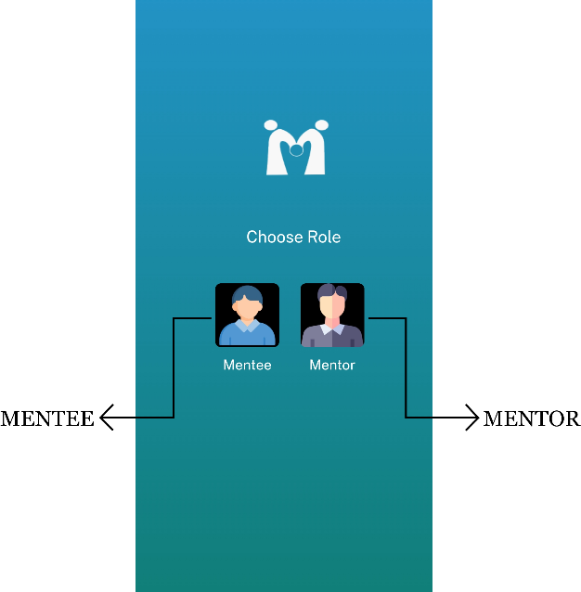Select your role, the options are **“Mentee”** and **“Mentor”**
2. Tap **“SIGN UP”** to create an account. Make sure to use your **“@dwc-legazpi.edu”** email.

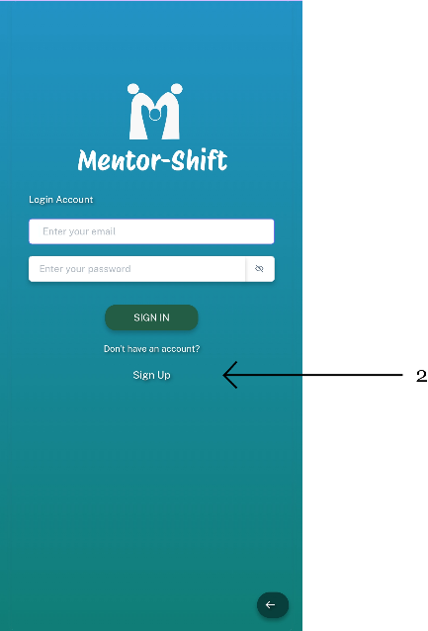

1. 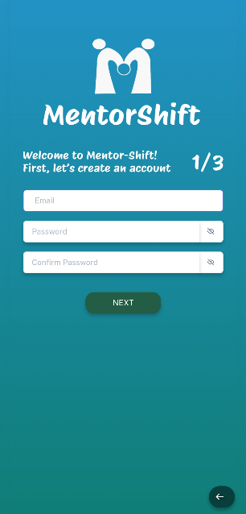Enter your **“EMAIL”** using the school account, and set your **“PASSWORD”.** Press **“Next.”**

1. You will enter your **“FIRST NAME”,** **“LAST NAME”, “GENDER”,** and **“BIRTHDATE.”** After that, press **“NEXT.”**

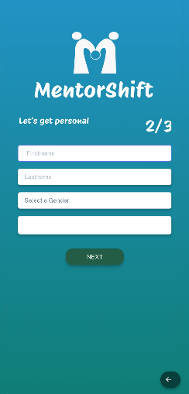

1. 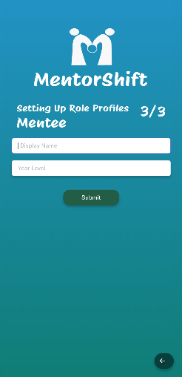 For **Mentee**,you will enter your preferred **“DISPLAY NAME”** and your **“YEAR LEVEL.”** After that, press **“SUBMIT.”.**
2. 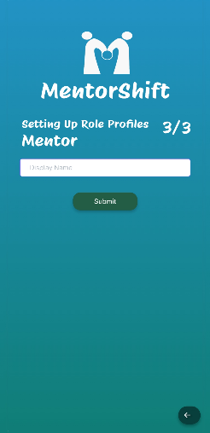While for **Mentor**,you will enter your preferred **“DISPLAY NAME”**. After that, press **“SUBMIT.”**
3. 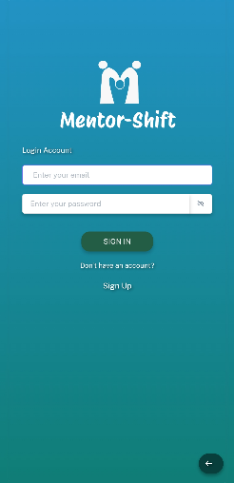You have now created an account. Enter your **“EMAIL”** and **“PASSWORD”** and press **“SIGN IN”** to log in.

**MENTEE SIDE:**

* + - 1. 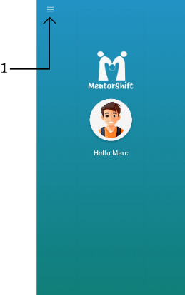After logging in, click the 3 lines at the top left.
      2. You will see options: **“HOME”, “INBOX”, “SET PROFILE PIC”, “CHANGE PASSWORD”, “BROWSE SUBJECTS”, “SUBJECT ENROLLED”,** and **“LOG OUT.”**
      3. 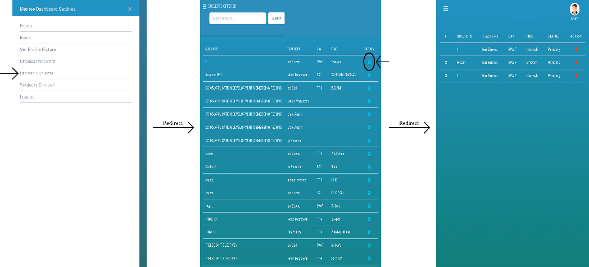Since you are a mentee, click **“BROWSE SUBJECTS”** to enroll in the subject you need. Click the blue button at the right to enroll to the subject. But before enrolling, you need to wait for confirmation from the professor. They will decide if you can enroll in their subject. You can check **“SUBJECT ENROLLED”** to see if you’ve been enrolled or declined.
      4. 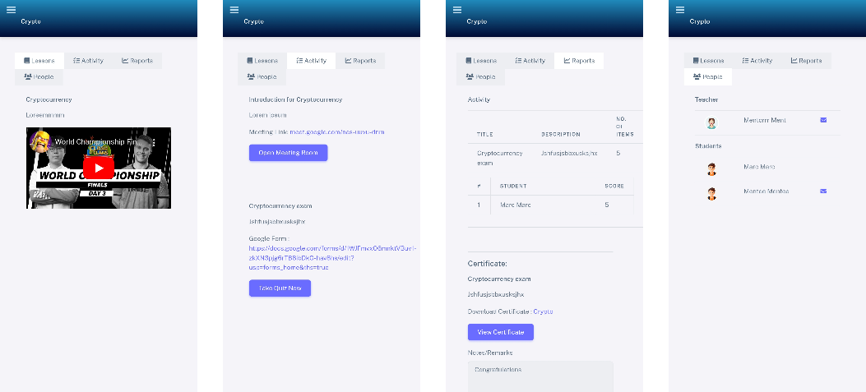If you have been enrolled, there will be a blue icon on the right side. Click it, and you will see four buttons: **“LESSONS”** (where the professor will post lesson files), **“ACTIVITY”** (where quizzes will be posted), and **“REPORTS”**.
      5. 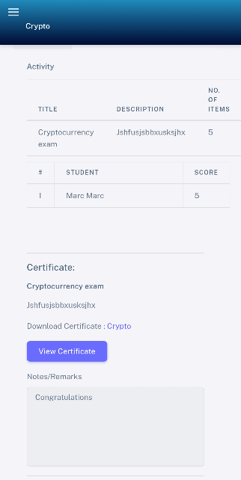After completing quizzes and finishing the subject, you can view your certificate by clicking **“REPORTS”**
      6. When you are done with everything, click **“LOG OUT.”**

**MENTOR SIDE:**

1. You will see the options: “**HOME**,” “**INBOX**,” “**SET PROFILE PIC**,” “**CHANGE** **PASSWORD**,” “**SUBJECTS**,” and “**LOG OUT**.”



1. Click **“SUBJECTS”** so that you can start adding the subjects you will teach. After clicking **“SUBJECTS,”** click the **“ADD”** button to add the subjects you want.

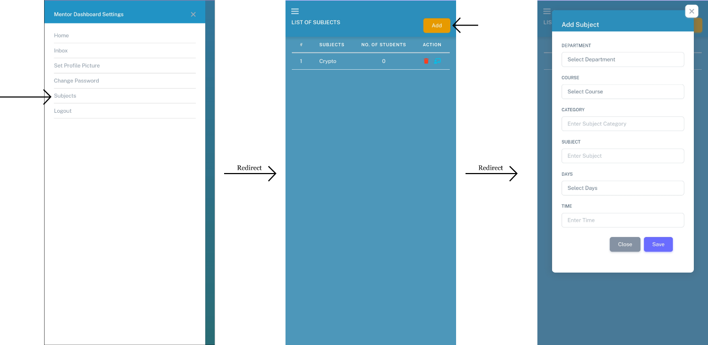

1. In the dashboard, you’ll see the subjects you added, along with **“SUBJECT,” “NO. OF STUDENTS,”** and **“ACTIONS.”**
2. 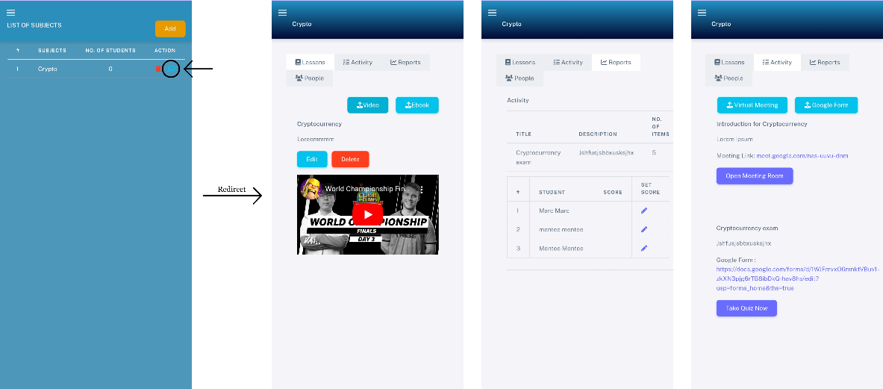In the subject action button, it will direct you to: “**LESSONS**” (where you will post lesson files), “**ACTIVITY**” (where you will upload quizzes), “**REPORTS**” (where you will track your students' progress).
3. 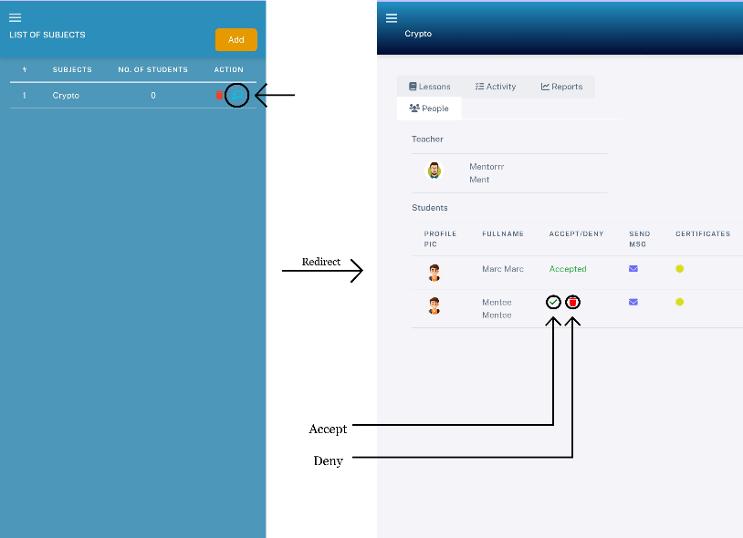In the **“PEOPLE”** button, Mentor can accept or decline the student enrollment. If Mentor accept, they will be automatically enrolled in your class.
4. 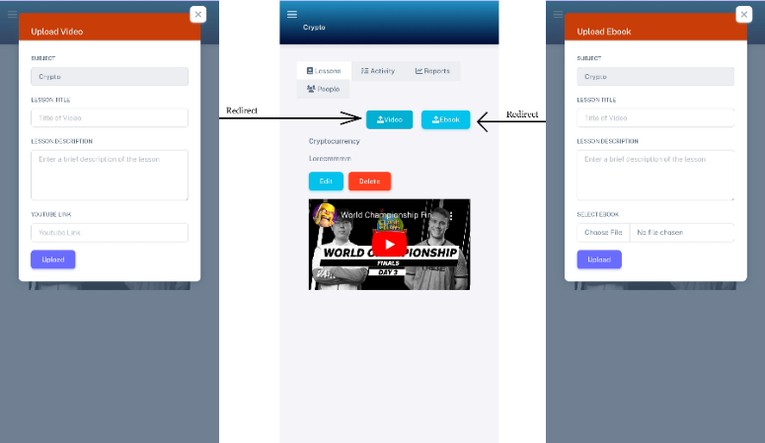You can add lessons by clicking “**VIDEO**” and “**EBOOK**.” You can choose to upload lessons as video url link from Youtube or PDF files.
5. 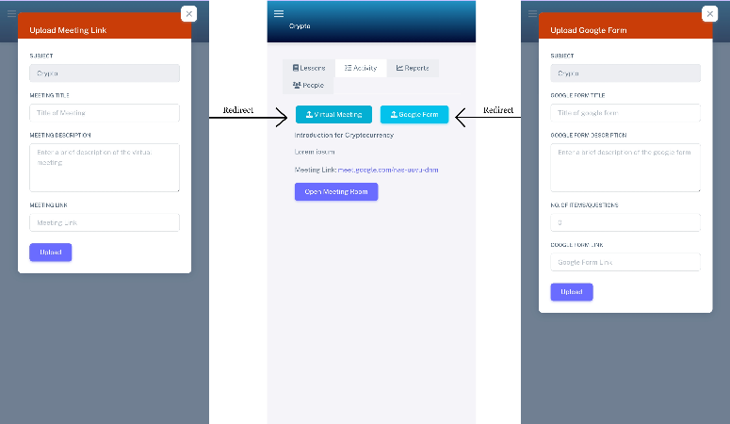If you want to hold a Google Meet, click the “**ACTIVITY**” button. There, you will see two options: “**Virtual meetings**” (to interact with your students online) and “**Google Form**” (this is where you will put your quizzes)
6. 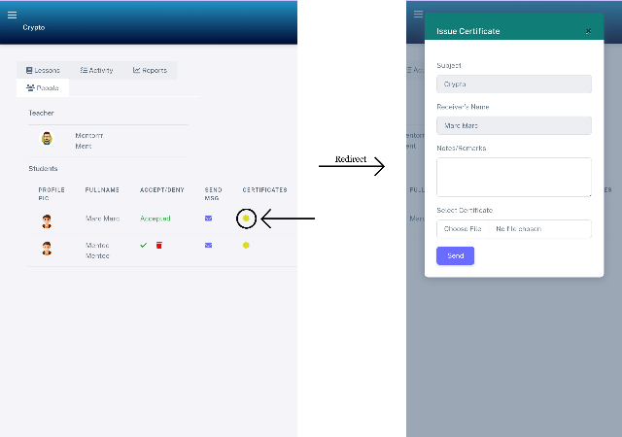After quizzes or when the term ends, you can issue certificates to your students. To do this, click the “**PEOPLE**” button, find the student you wish to give the certificate to, and click the “**CERTIFICATE**” button next to the “**MESSAGE**” button.
7. When the session is done, click the **“LOG OUT”** button.

**CURRICULUM VITAE**

**JADE BUBAN RAPOSA**

San Pedro, Santo Domingo, Albay

+63 9471918324

jaduya678@gmail.com

**PERSONAL INFORMATION:**

Birthdate : February 19, 1998  
Civil Status : Single

Gender : Male

Religious Affiliation : Roman Catholic

**EDUCATIONAL ATTAINMENT:**

Tertiary : Divine Word College of Legazpi

Course: BS Information Technology

Secondary : Sto. Domingo National High School, Year Graduated: 2015

Elementary : Saint Raphael Academy, Year Graduated: 2011

**CURRICULUM VITAE**

**IAN JAY NICCOLO BUENO**

\_\_\_, \_\_\_\_\_\_\_\_, Masbate

+63 \_\_\_\_

\_\_\_\_\_\_\_\_\_@gmail.com

**PERSONAL INFORMATION:**

Birthdate :   
Civil Status : Single

Gender : Male

Religious Affiliation : Roman Catholic

**EDUCATIONAL ATTAINMENT:**

Tertiary : Divine Word College of Legazpi

Course: BS Information Technology

Secondary : MOBO National High School, Year Graduated: 2021

Elementary : MOBO North Central School, Year Graduated: 2015

**CURRICULUM VITAE**

**MARC AUSTIN BONAGUA**

San Ramon, Tabaco City, Albay

+63 931-9338-480

marcaus07@gmail.com

**PERSONAL INFORMATION:**

Birthdate : August 7, 2003  
Civil Status : Single

Gender : Male

Religious Affiliation : Roman Catholic

**EDUCATIONAL ATTAINMENT:**

Tertiary : Divine Word College of Legazpi

Course: BS Information Technology

Secondary : Tabaco National High School

Year Graduated : 2021

Elementary : Tabaco South Central Elementary School Year Graduated : 2015